Unmanaged Layer Scanner
Technical reference
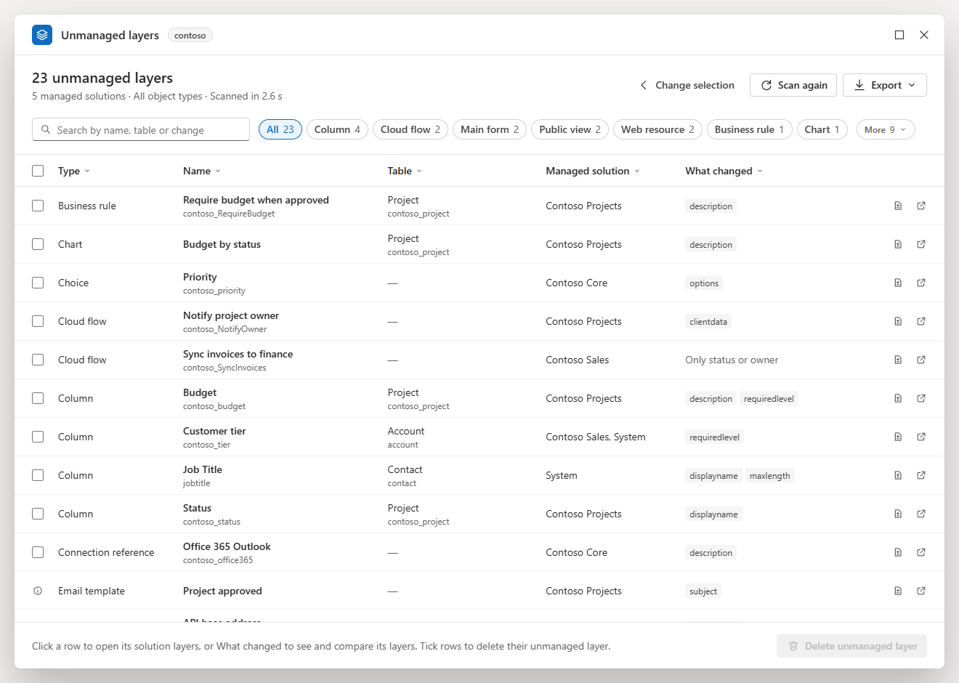
Version 6.3.0 · 2026-10-15
github.com/kevins/UnmanagedLayerScanner
MIT License. Copyright (c) 2026 KV.
Contents
Features 5
Screenshots 7
Choosing what to check 7
Results and filters 10
Details of a component 13
Deleting layers 20
Narrow window 23
Download 23
Install 24
Drag the button 24
Create the favourite by hand 24
Run it from the console 25
When bookmarklets are blocked 25
Update to a new version 25
Use 25
Open it 25
Choose what to check 26
Scan and stop 27
The results 28
Type bubbles 29
Column menus 29
Which page a row opens 30
Banners 31
The details 31
What changed 31
Layers 33
JSON 33
Export 33
Deleting 34
Outcomes 35
The deletion log 36
Keyboard 37
Environment rules (optional) 37
Safety 39
Messages 40
Starting 40
Choosing 41
Scanning and results 42
Details 43
Deleting 44
Troubleshooting 45
Limitations 47
How it works 49
Comparison with Solution Layers Explorer 50
Repository layout 52
Build 52
License 53

A bookmarklet for Microsoft Dataverse (Dynamics 365 and Power Apps) that finds the components of managed solutions that have an unmanaged (Active) layer on top: the changes made directly in an environment, which hide what later deployments of the managed solutions bring. It shows what each layer changes, comparing any two layers property by property, and deletes the unmanaged layer when asked, one component at a time, checked before and after.
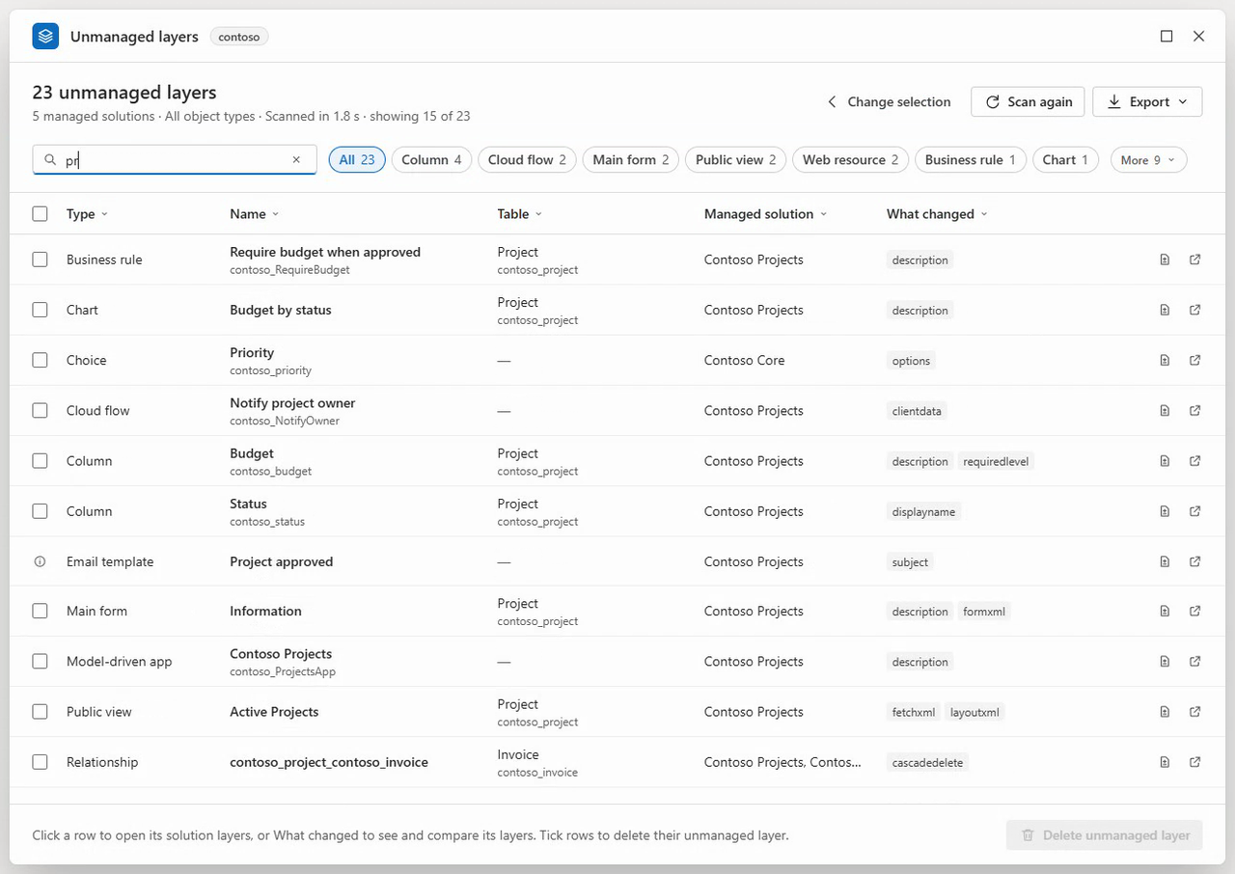
The same demo as a video (MP4).
Item | Value
Tool | A bookmarklet: a favourite whose address is a small program. On the favourites bar it is named Unmanaged layers. Version 6.3.0
Runs on | Any page of a Dataverse environment (https://<org>.crm.dynamics.com, for example a model-driven app), or the environment's pages in the maker portal (make.powerapps.com), with your own sign-in. See Open it
Browser | Microsoft Edge, the supported and tested browser. The link unpacks itself with the browser's DecompressionStream
Link size | About 70,500 characters: the code is compressed inside the link and unpacked by the browser
Installs in the environment | Nothing: no solution, no app registration, no server code. The scan only reads; see Safety
Documentation | Technical reference (Word)  Developer guide: how the scanner is built and how to change it (also as Word)
License | MIT

Why. Solution Layers Explorer reads the layers of every component of a solution one by one, so checking a whole environment means tens of thousands of lookups and takes hours. The scanner asks Dataverse once per component type for the managed components whose top layer is unmanaged, and then reads the layers of those components only. In a test environment with about 950 tables, 37,000 columns and 517 managed solutions, a full scan took about 30 seconds and 450 requests; Solution Layers Explorer's way, about 83,000 lookups, was estimated at 1.7 to 3.5 hours.
Deleting cannot be undone. Deleting an unmanaged layer is the same as Remove active customizations on the Solution layers page: the component goes back to what its managed solutions define, and the changes made directly in the environment are gone. Try the scanner in a test environment first, and download the deletion log after each run.

Features
Screen | What you see
Choose what to check | Every managed solution of the environment, with a search box and a switch for Microsoft and hidden solutions; the object types, grouped as in the maker portal; an optional limit to some tables; saved selections; Scan
Choose tables | The environment's tables (display and logical names), searchable, with Selected only
Scanning | The step being worked on with a percentage, a progress bar, placeholder rows the size of the final ones, and Stop scan
Results | The number of unmanaged layers, a search box, type bubbles, and a grid of five columns (Type, Name, Table, Managed solution, What changed), each with an Excel-like menu; Export
Details of a component | Three tabs: What changed (any two layers compared property by property), Layers (every layer, as on the Solution layers page) and JSON (each layer's Changes, All properties and Children)
Delete confirmation | One dialog listing every ticked component, in the order they will be deleted
Deleting | The row being deleted, how many are done, the time left and Stop deleting; when the window is closed, a pill in the corner of the page
After deleting | The deleted rows struck through with a green check, a message with the counts and Download log

- Only what matters. A component is listed when it belongs to a managed solution you chose and has an unmanaged layer on top. Unmanaged solutions, and components that exist only unmanaged, are never listed or checked.
- Choose the scope. Any number of managed solutions (Microsoft's hidden base solutions too, such as System, which holds the standard tables), some object types only (for example Forms and Views), and optionally some tables only. Fewer types or tables make the scan faster.
- Saved selections. Name a choice of solutions, types and tables, and pick it again from a menu. The last choice is remembered for each environment.
- Works on the maker portal too. Started on an environment's Solutions pages in the maker portal, the scanner uses the portal's own sign-in; started on a solution's page, that solution is selected.
- Results you can work with. A search box, type bubbles (All, then each type with its count; types that do not fit go under More), and on every column an Excel-like menu: sort, search the column's values, tick the values to show, each with how many rows have it. Columns can be resized, or fitted to their contents.
- One click to the Solution layers page. A click on a row opens the component's solution layers in a new tab, in the managed solution it was found in.
- What changed, in detail. Any two layers of a component compared property by property: XML laid out one attribute per line, JSON indented, web resource content decoded and images shown as images, inline or side by side, with unchanged lines folded. The layout never changes a value: two values that differ never look the same. Every value has Copy, which copies it exactly as stored.
- Exports. The rows shown (CSV), every layer of each component (CSV), everything the scan found (JSON), and the deletion log (CSV).
- Careful deleting. One confirmation for the ticked components; then one component at a time, top to bottom in the order shown. Right before each one its layers are read again; right after, the unmanaged layer must be gone and every managed layer as before (the same solution, order, publisher and values). Deleting can be stopped, and continues when the window is closed.
- A window that stays out of the way. It floats over the page: move it by its title bar, resize it from any edge or corner, maximize it. Its place and size are remembered. The page around it stays usable.
- Keyboard and screen readers. Every control works from the keyboard, with menus, lists and tabs that behave as in Fluent (Microsoft's design system, which the window follows); progress and results are announced.
- Read-only scan. Every request of the scan, the details and the deletion goes through one function, which refuses anything but a read unless a confirmed deletion is running. See Safety.
- Your own sign-in, nothing installed. The scanner runs in your browser with your own privileges. It installs nothing in the environment and sends requests to Dataverse's Web API only (on the maker portal, before it starts, it asks the Dataverse addresses the portal holds a sign-in for which one is the open environment).

Screenshots
The screenshots show a fictitious environment, contoso.

Choosing what to check
Choose what to check. Five managed solutions selected, with Show Microsoft and hidden solutions on (System, which holds the standard tables, is ticked at the bottom), every object type, and every table.
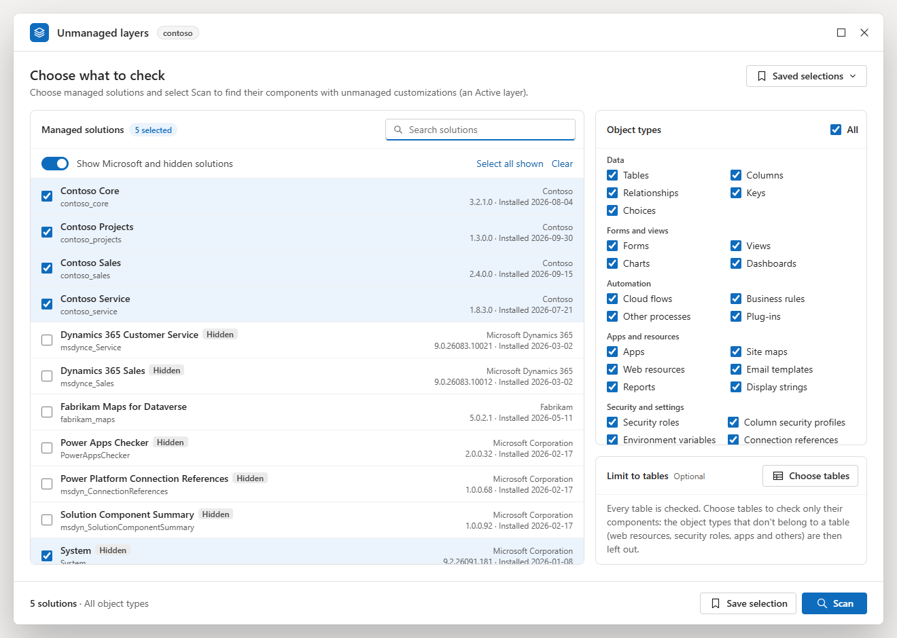
Choose tables. The search contoso finds four tables, and Project is ticked: only the components of that table are then checked.
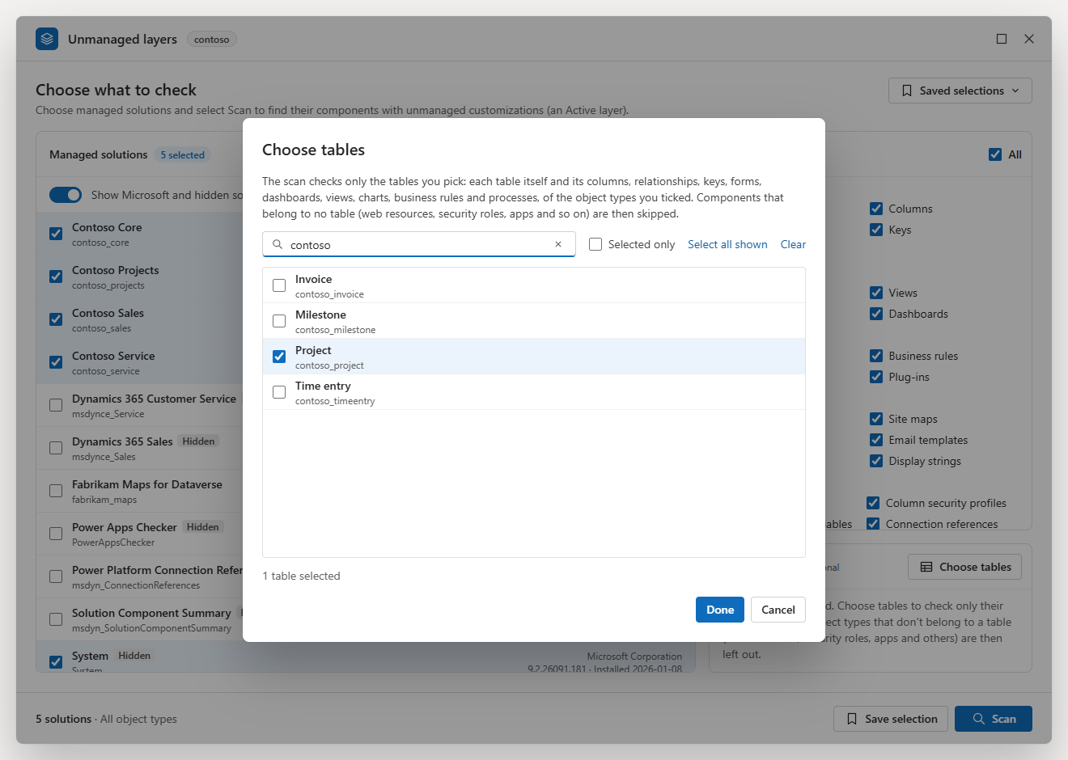
Scanning. The step being worked on and how far the scan is, placeholder rows, and Stop scan.
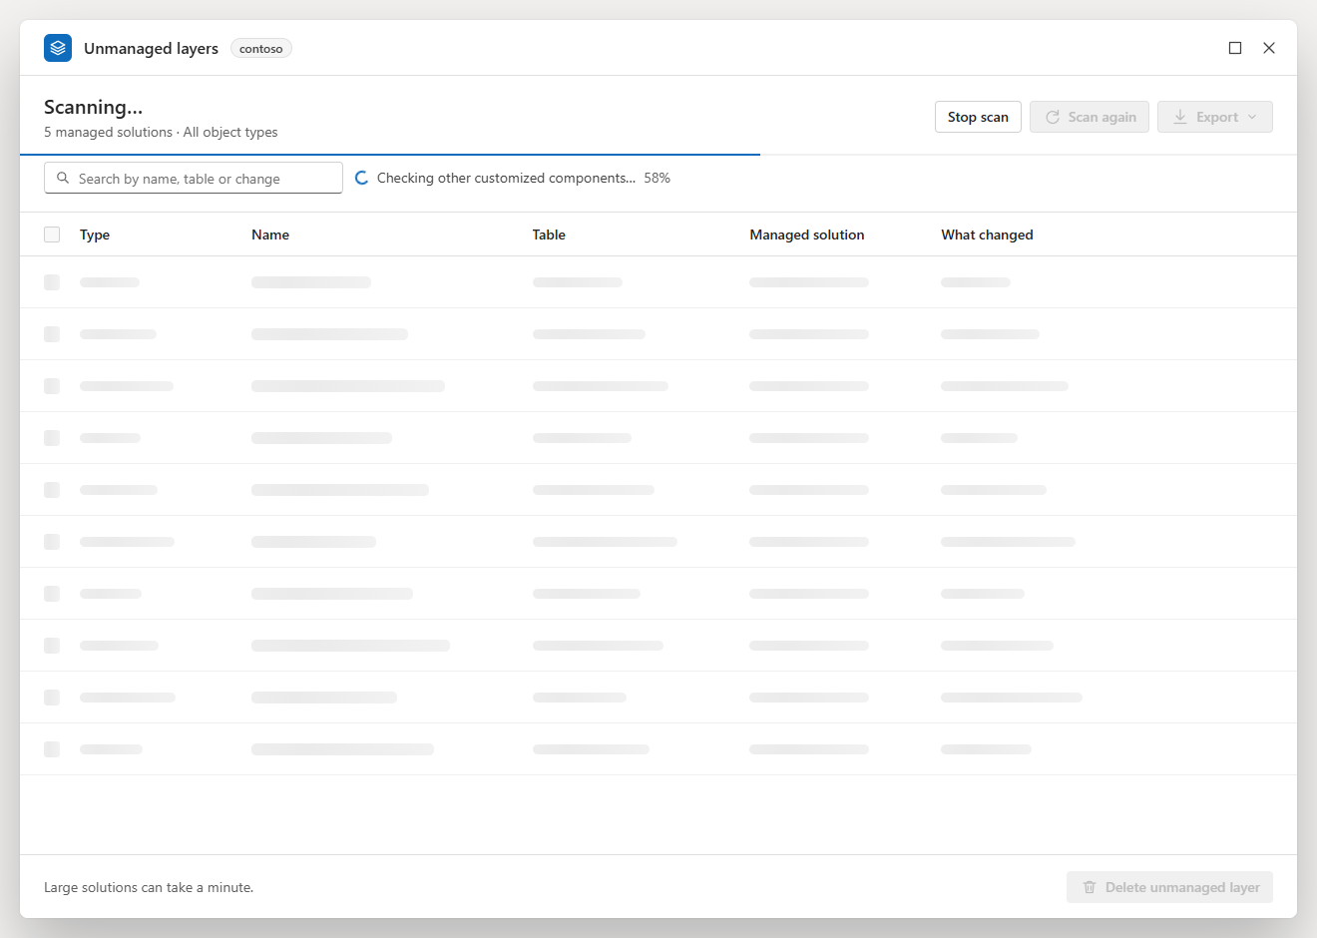

Results and filters
The results. 23 unmanaged layers in the five solutions, scanned in 2.5 s. The type bubbles show the most common types first, and the nine others are under More. Each row shows the type, the name with the schema name under it, the table, the managed solution and the properties the unmanaged layer changes. The email template has an info icon instead of a tick box: Dataverse does not allow deleting its unmanaged layer.
A column's menu, here What changed: sort, search, and every property name with the number of rows that change it.
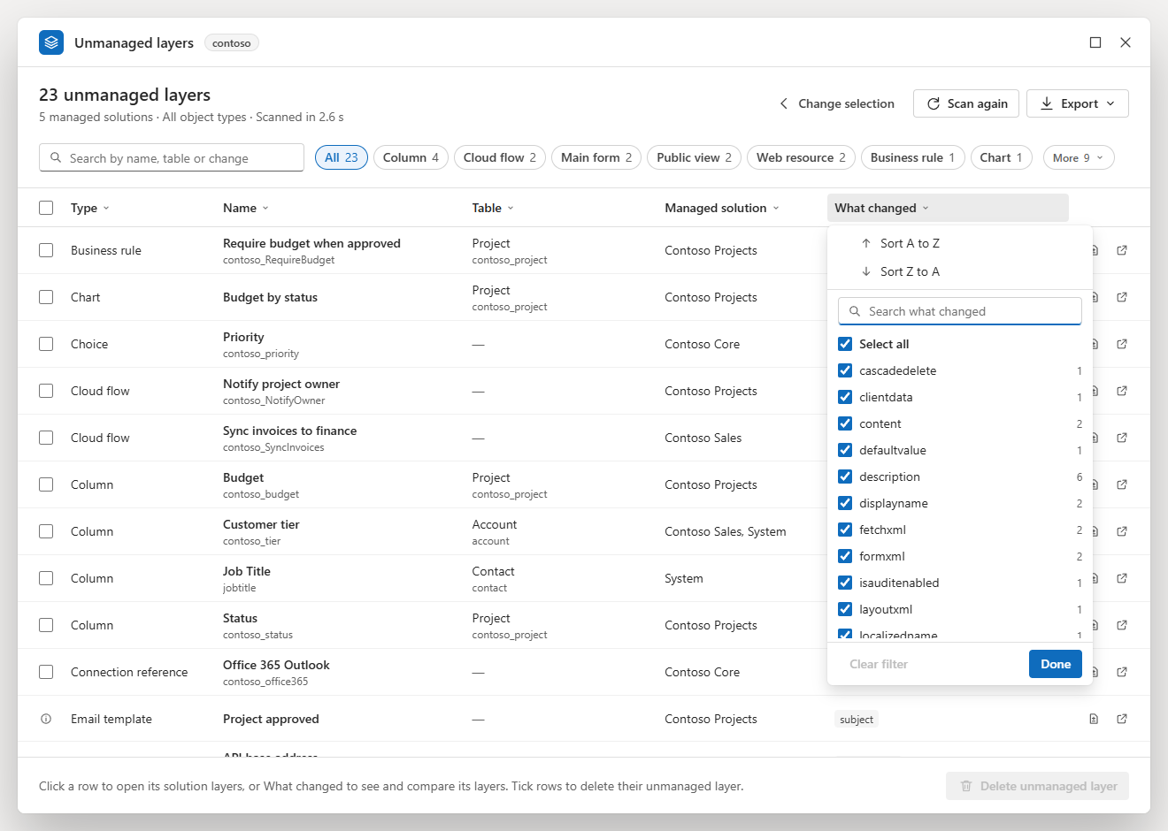
Export: the rows shown, every layer of each component shown, or everything the scan found.
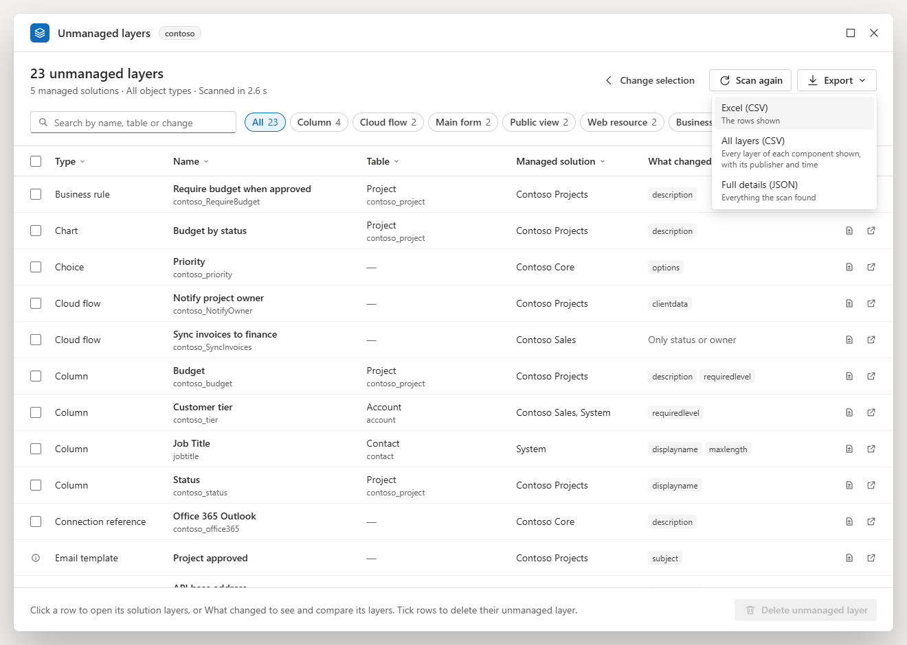

Details of a component
What changed for a main form: the managed layer of Contoso Projects 1.3.0.0 (red) against the Active layer (green). The description is short, so both values are shown one above the other. The form's XML is laid out one attribute per line and compared line by line, with the changed part of each line marked and the unchanged lines folded. Three system values that also differ are hidden.
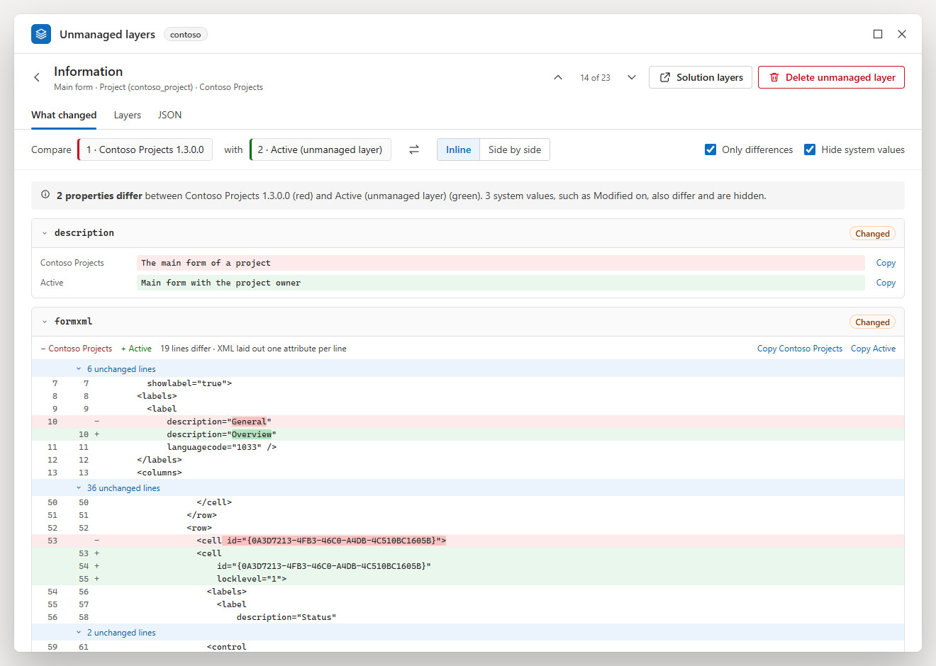
Side by side, for a JavaScript web resource: its content is decoded from base64 and compared line by line, the managed layer on the left and the Active layer on the right.
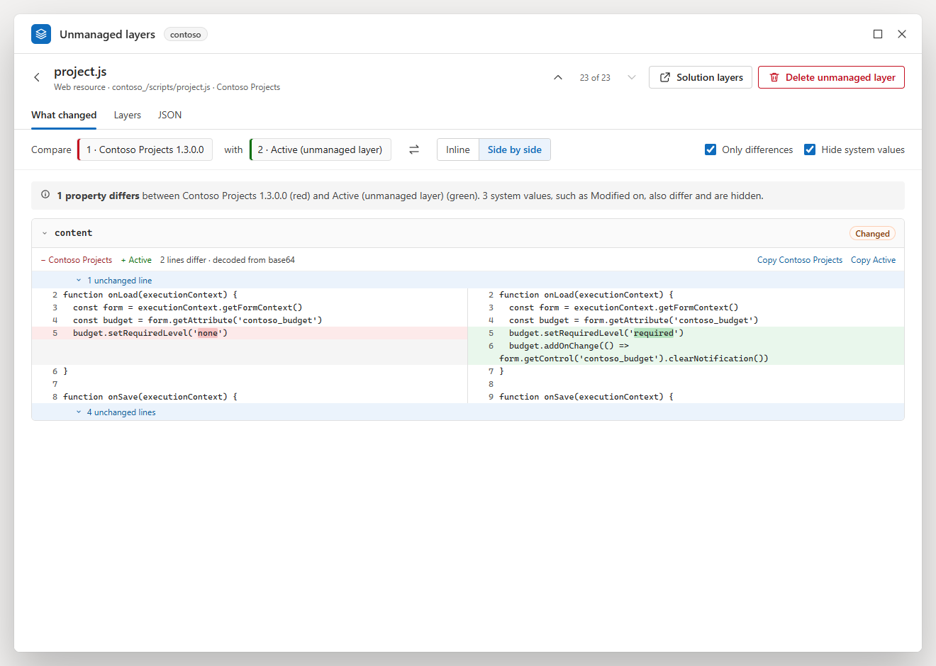
An image web resource: both images are shown, with their sizes.
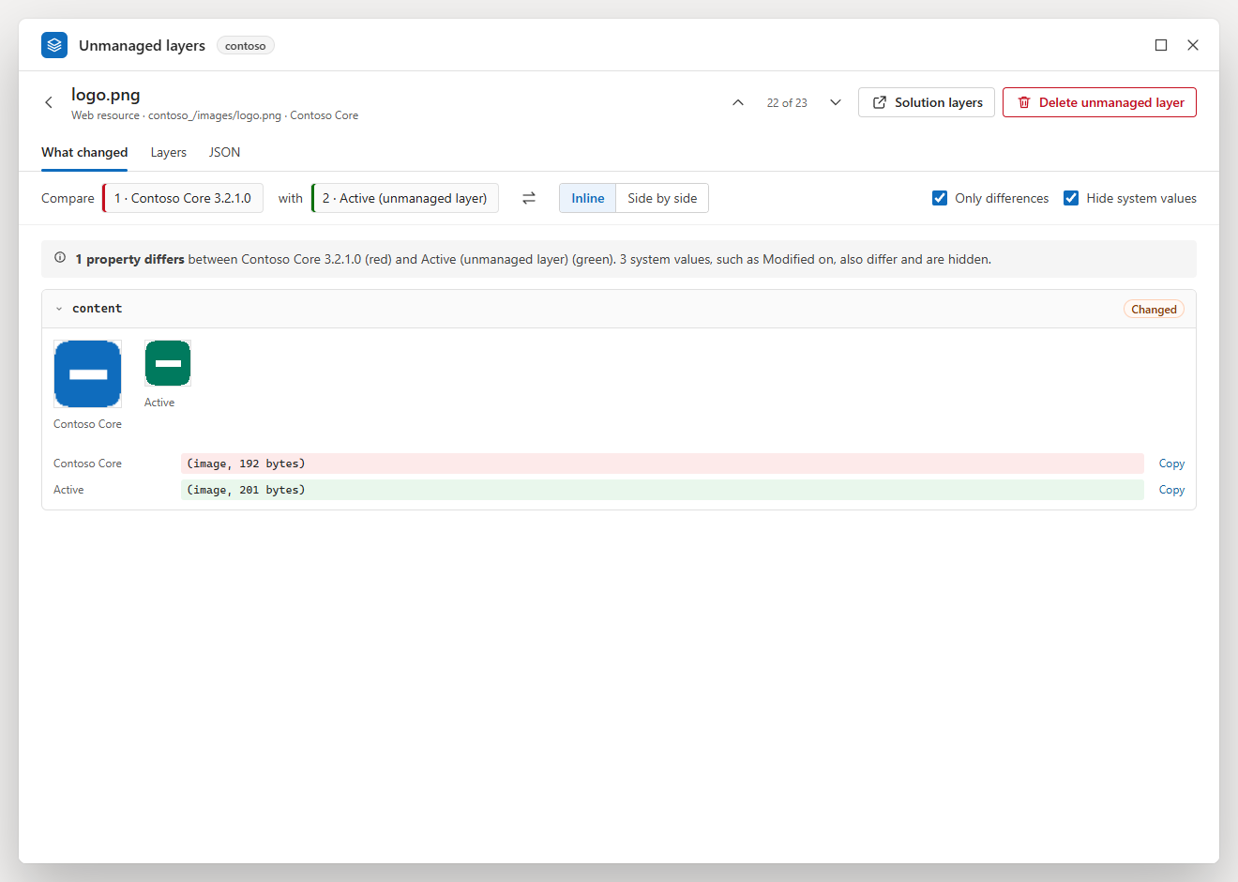
A web resource whose content is kept as a file: the content is one row, content. Dataverse gives out only the file in effect, here the Active layer's, so the Active layer's content is shown, decoded, with Copy Active. The managed layer's file can't be read, so its line says so: its content is not guessed, and the two are not compared line by line (see What changed).
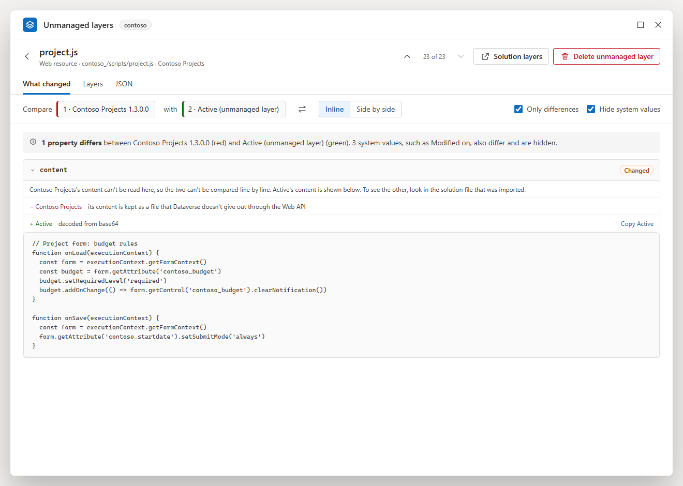
The Layers tab: every layer of the component, top first, with its solution, publisher, kind, version, overwrite time and number of changed properties. Compare with Active and JSON open the other tabs on that layer.
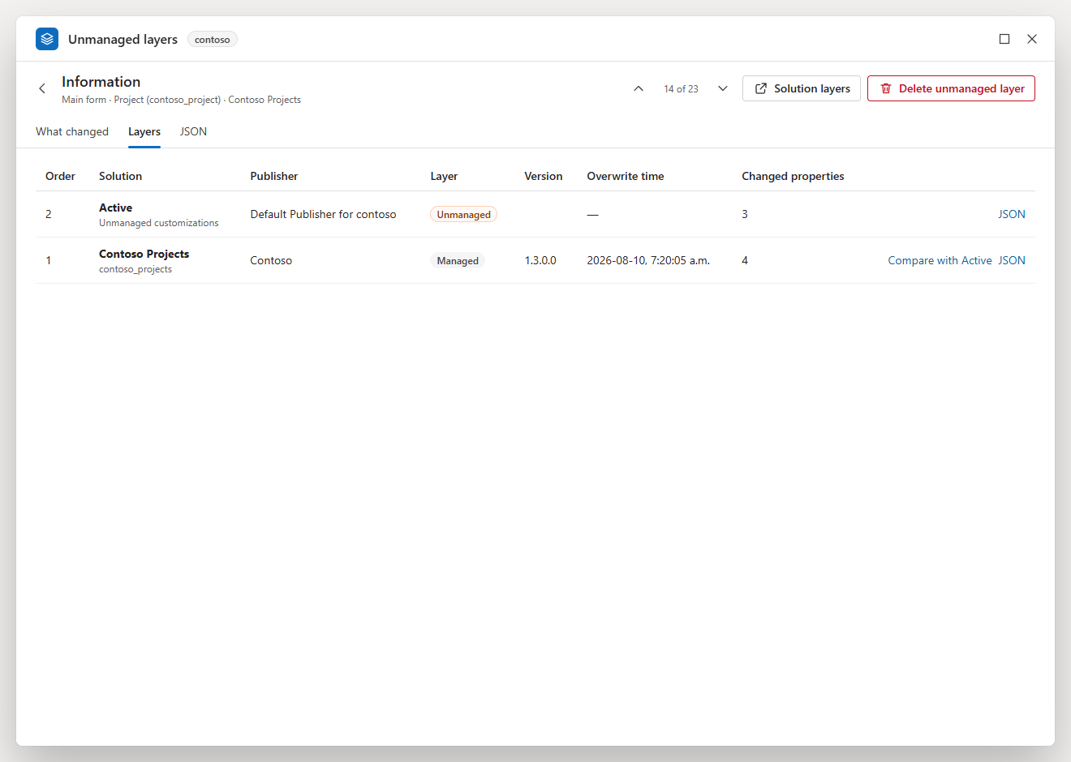
The JSON tab: the Active layer's changes, indented and coloured, with Copy and Download.
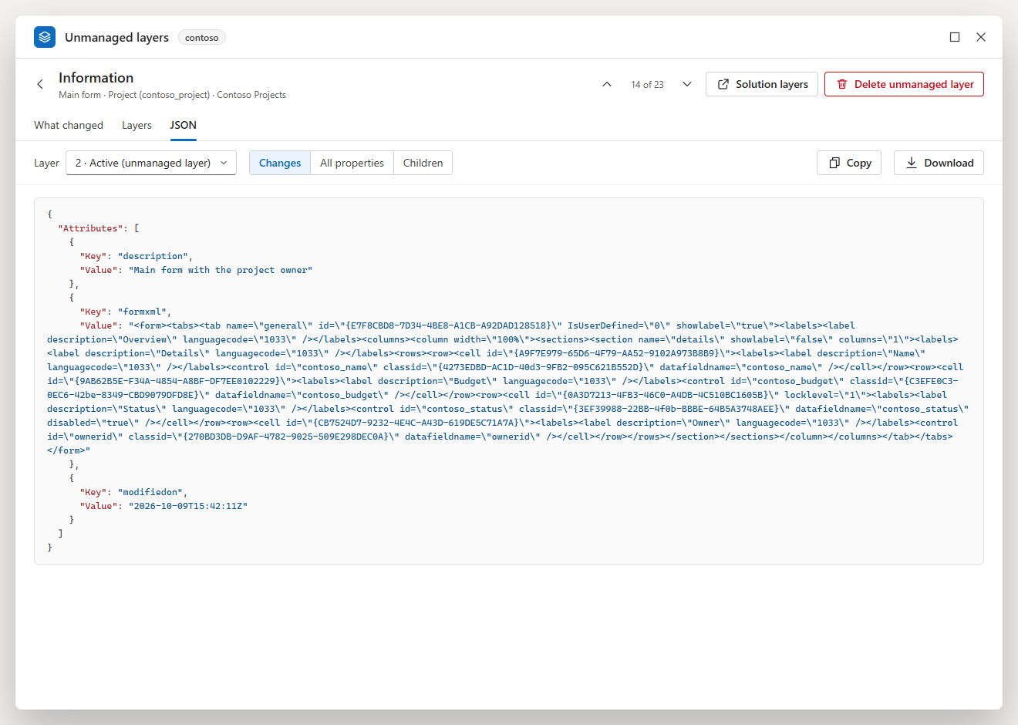
Children as a table: a security role's privileges with their depth named (Organization, Business unit, Parent: child business units), above the JSON they come from.
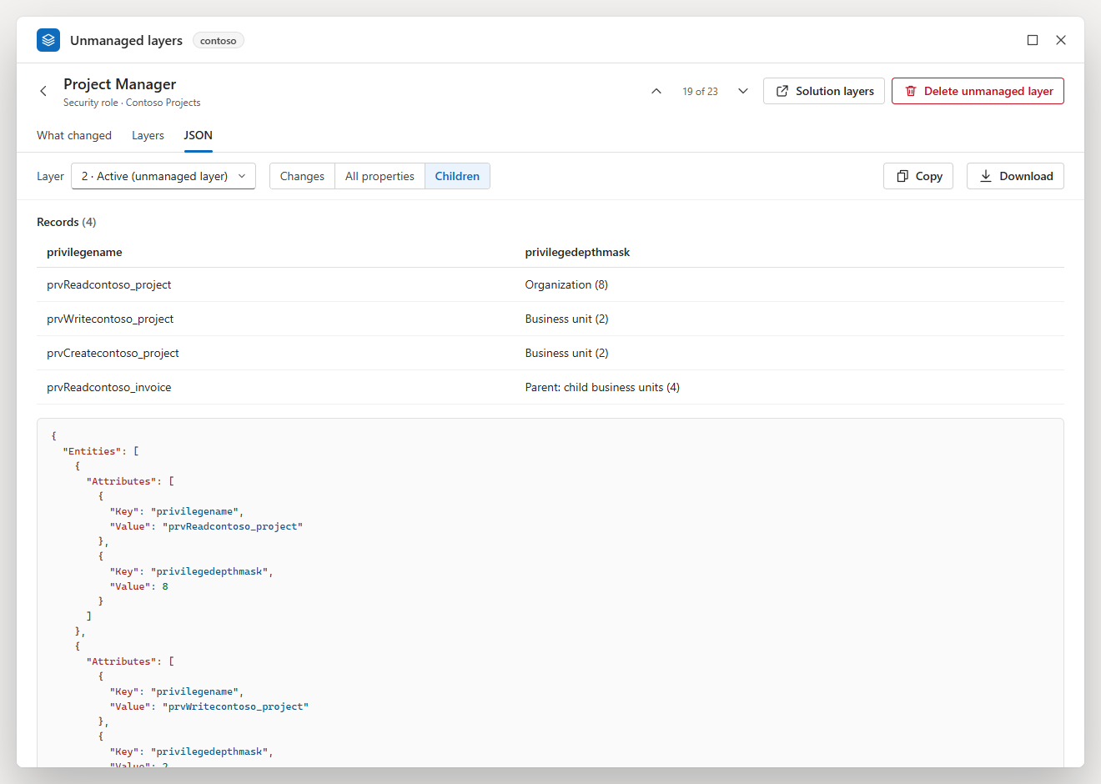

Deleting layers
One confirmation for three ticked components, listed in the order they will be deleted. Cancel has the focus.
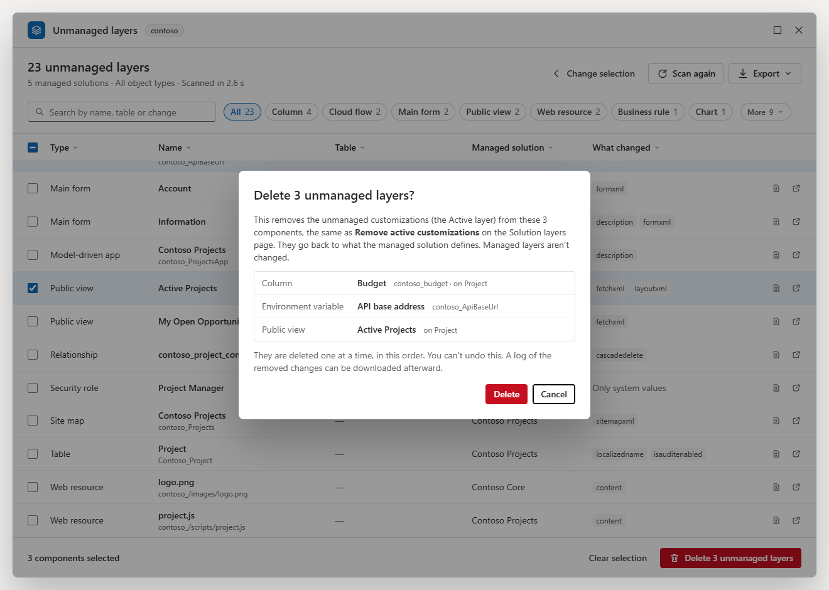
Deleting. The first component is done and struck through, the second is being deleted; the bottom bar shows the progress, the time left and Stop deleting.
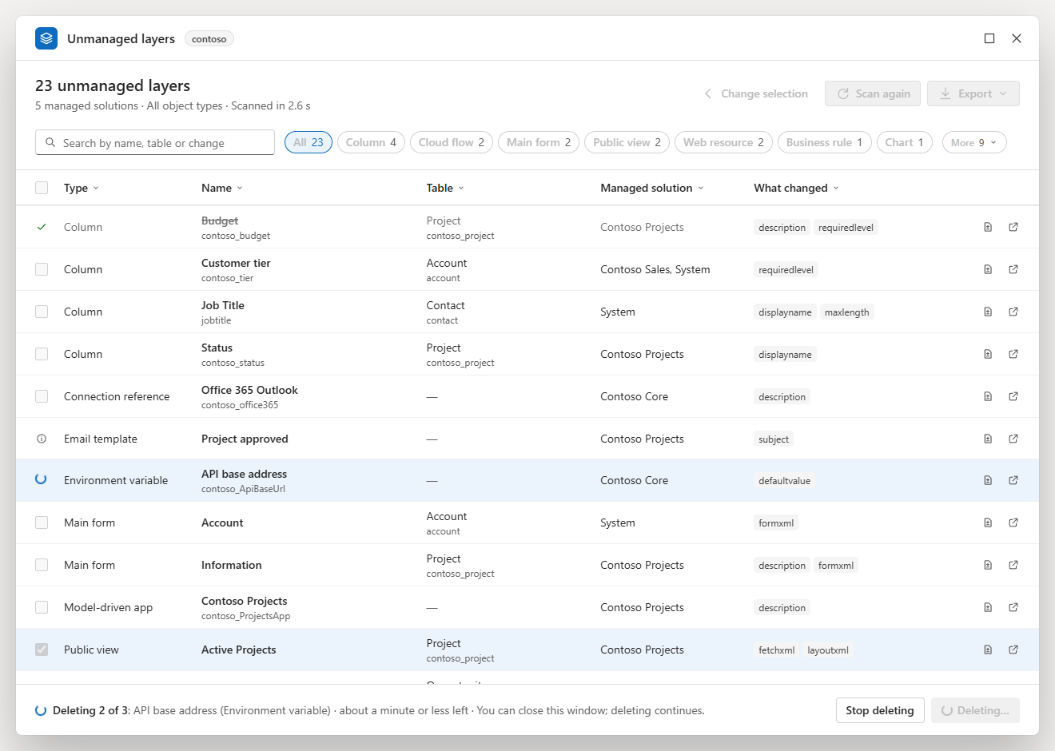
After deleting. The three rows are struck through with a green check, the title counts 20, and the message offers the deletion log.
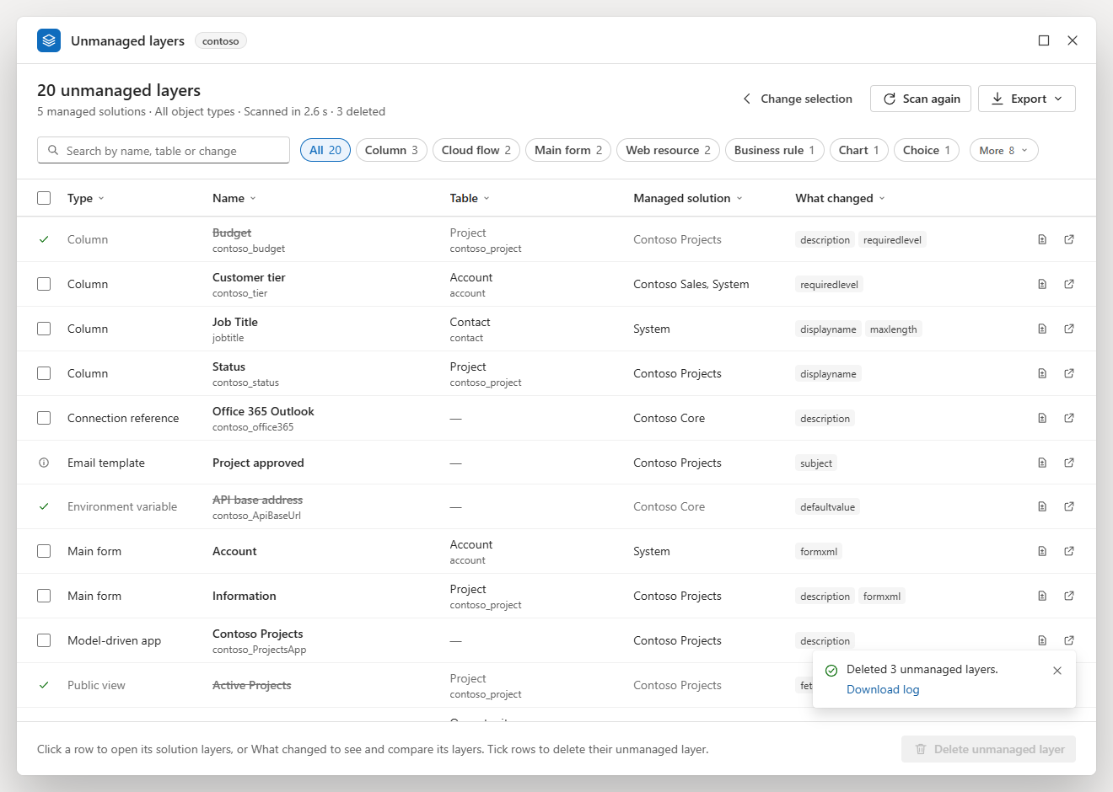

Narrow window
A narrow window. The object types go to one column and the cards make room. Back to results returns to the last scan's results.
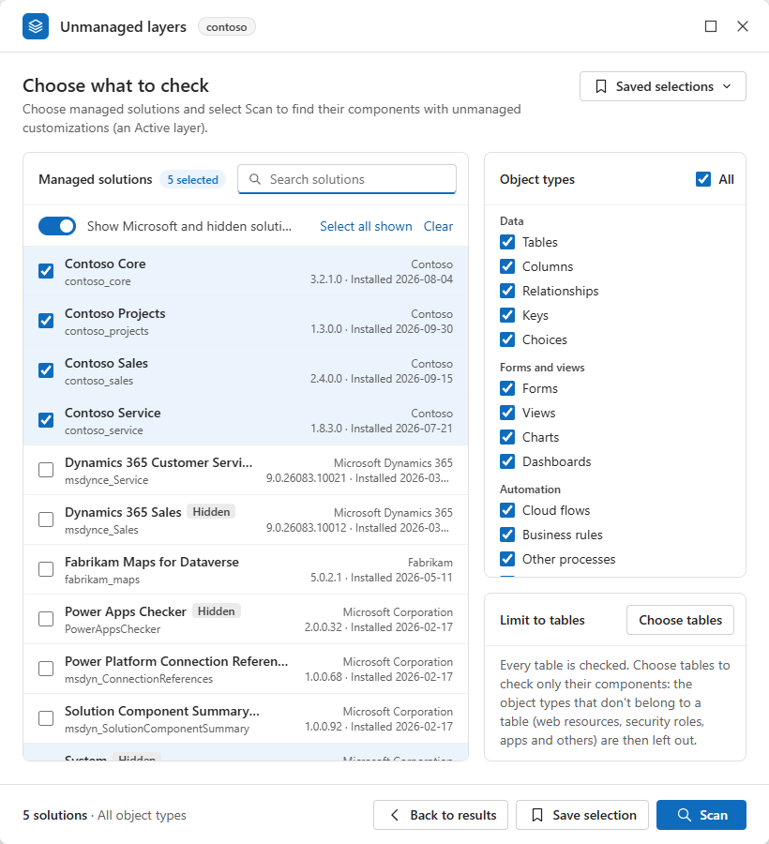

Download
The files are attached to each release on the Releases page:
File | Use
Install-unmanaged-layer-scanner.html | The install page: open it in Edge and drag the Unmanaged layers button to the favourites bar. It also holds the link in a box with Copy. Most people need only this file (in the repository it is Install unmanaged layer scanner.html)
layer-scanner.bookmarklet.txt | The link itself (it starts with javascript:), to paste as the address of a favourite
layer-scanner.min.js | The scanner's code, minified, to paste into the browser's console where bookmarklets are blocked
UnmanagedLayerScanner-Technical-Reference.docx | This README as a Word document: installing and using the scanner, step by step with screenshots
UnmanagedLayerScanner-Developer-Guide.docx | The developer guide as a Word document: how the scanner is built and how to change it
README.txt | The package in short: what each file is, how to install, and the checksums
SHA256SUMS.txt | The SHA-256 checksums of the release's files, one line per file

To check a file against its checksum in PowerShell: Get-FileHash -Algorithm SHA256 .\layer-scanner.bookmarklet.txt, then compare the hash with the line for that file in SHA256SUMS.txt (PowerShell prints it in capitals). On macOS or Linux, sha256sum -c SHA256SUMS.txt checks every file it lists at once.
The released files are built from this repository without environment rules. To build them yourself, see Build.

Install

Drag the button
- Download Install-unmanaged-layer-scanner.html from the Releases page and open it in Edge (double-click it, or drag it onto an Edge window). GitHub shows the copy in the repository as source text, so use the downloaded file.
- Show the favourites bar: Ctrl+Shift+B.
- Drag the blue Unmanaged layers button onto the favourites bar.

Create the favourite by hand
When dragging does not work:
- Copy the link: Copy on the install page, or the whole content of layer-scanner.bookmarklet.txt.
- Add any page to the favourites bar (Ctrl+D, folder Favourites bar).
- Right-click the new favourite, select Edit, name it Unmanaged layers, replace its URL with the link, then Save.

Pasting the link into the address bar does not run it: the browser removes the javascript: part of pasted text.

Run it from the console
Without a favourite, the same code runs from the browser's developer tools:
- Open a page of the environment, or its Solutions page in the maker portal.
- Press F12 and open Console.
- Paste the whole content of layer-scanner.min.js and press Enter. If the console warns about pasting code, follow the instruction it gives to allow pasting (in Edge, type allow pasting, then paste again).

When bookmarklets are blocked
Some organizations block bookmarklets with a browser policy: clicking the favourite then does nothing. Use the console (above), or ask the people who manage your browser.
The link runs the unpacked code with eval. If a page forbids that, the link loads the code as a script instead; if that is refused too, it says "This page does not allow the unmanaged layer scanner to run." Environment pages and the maker portal allow it.

Update to a new version
- Replace the favourite's URL with the new link (right-click it, Edit), or drag the new button from the new install page and delete the old favourite.
- Reload the pages where the scanner's window is open. On a page where a window is already open, the favourite shows that window again instead of starting the new version.

Saved selections, the last choice, the column widths and the window's place and size are kept. To see which version runs, point at Unmanaged layers in the window's title bar: the tooltip reads "Unmanaged layer scanner 6.3.0".

Use

Open it
Click Unmanaged layers on the favourites bar:
- On a page of the environment: any address ending in .dynamics.com, for example https://contoso.crm.dynamics.com/main.aspx. The scanner uses your browser's session with the environment.
- In the maker portal: make.powerapps.com with an environment open (the address contains /environments/<id>/), for example its Solutions page. Wait until the Solutions list has loaded: the scanner uses the portal's own sign-in to the environment (see Safety). Started on a solution's page, that solution is selected, with every object type and every table, and the bottom bar says "selected because it's open in the maker portal".

The window opens over the page. Its title bar shows the environment's name (point at it to see the address) and, with environment rules, a Production or Development badge.
There is one window per page. Clicking the favourite again shows the same window as you left it; in the maker portal, on the page of another managed solution, it goes back to the choice with that solution selected. When you switch to another environment in the maker portal, the next click closes the old window and starts one for the new environment (not while it is scanning or deleting); download the deletion log first, because it goes with the old window. To close the window, select × or press Esc.

Choose what to check
Managed solutions. Every managed solution of the environment, with its display name, unique name, publisher, version and installed date; hidden solutions carry a Hidden tag. Unmanaged solutions are not listed. Search by name, unique name or publisher. Select all shown ticks the solutions in the list, Clear unticks them all.
Show Microsoft and hidden solutions is off by default: the list then leaves out hidden solutions and solutions whose publisher's name contains "Microsoft" or "Dynamics 365", except those already ticked.
Why System matters. Standard tables such as Account and Contact, with their standard columns, forms and views, belong to Microsoft's hidden base solutions, mainly System. A standard component changed directly in the environment has its unmanaged layer on top of System's layer. If you tick only your own solutions, such changes are not listed. To include them, turn on Show Microsoft and hidden solutions and tick System too (or select all). In the results screenshot, the changed column Job Title of Contact is found through System.
Object types. The types to check, grouped as in the maker portal:
Group | Types
Data | Tables, Columns, Relationships, Keys, Choices
Forms and views | Forms, Views, Charts, Dashboards
Automation | Cloud flows, Business rules, Other processes, Plug-ins
Apps and resources | Apps, Site maps, Web resources, Email templates, Reports, Display strings
Security and settings | Security roles, Column security profiles, Environment variables, Connection references
Everything else | Other: every other component type, for example ribbon customizations, duplicate detection rules and component types added by newer solutions

All ticks or clears every type listed. With some types only, the scan reads only the component types they need, which is faster.
Limit to tables (optional). By default every table is checked. Choose tables opens the environment's tables (display and logical names; private tables are not listed), with a search box, Selected only, Select all shown and Clear. With tables chosen, only their components are checked: the tables themselves and their columns, relationships (on either side), keys, forms, dashboards, views, charts, business rules and other processes, of the object types ticked (under Other, only their ribbon customizations). Object types that are not offered for a table (choices, cloud flows, plug-ins, apps, web resources, security roles and others) are then no longer listed, with a note; they come back with their ticks when you select Check all tables. This is also faster: in a test, one table took about 9 seconds and 32 requests, against 15 to 25 seconds and about 310 to 330 requests for the same solution with every table.
Saved selections. Save selection (bottom) names the current choice of solutions, types and tables; the name can be up to 60 characters long, and saving under an existing name replaces it (the button then says Replace). The Saved selections menu (top right) lists them with what each holds; pick one to fill in the choice (then select Scan), or select its bin icon to remove it (Undo in the message puts it back). Applied in an environment that lacks some of its solutions, a saved selection says which; saving it again there keeps them in it.
Saved selections are kept in this browser: on the maker portal they are shared by every environment, on an environment's own pages they belong to that environment. The last choice you scanned is remembered for each environment and filled in next time.
The bottom bar sums up the choice, for example "5 solutions · All object types", and Scan starts.

Scan and stop
While scanning, the title says Scanning…, and next to the search box a line names the step and the percentage:
Step | What it reads
Reading tables… | The tables, which of the columns the scan needs each table has, and the component type definitions
Checking component types (n of m)… | One query per component type: its managed components whose top layer is unmanaged
Checking tables, columns and relationships… | The definitions of the tables, columns, keys and relationships found, to keep the managed ones
Checking other customized components… | The maker portal's Customized flag, for the types the queries above cannot read (global choices and others)
Finding which solutions the components are in… | The solution memberships of the components found, 50 at a time
Checking the remaining components (n of m)… | The layers of components that have no solution membership row, to place them in a solution
Reading what changed (n of m)… | The layers of the components found: the managed layers underneath and what the unmanaged layer changes

Stop scan ends the scan: the reads waiting or on their way end at once, the window goes back to the choice, and a message says "Scan stopped." Nothing partial is shown.
In a test environment, a scan of every managed solution took about 30 seconds, and a scan of one solution with every object type 15 to 25 seconds: the time follows the number of component types read, not the number of solutions. A few object types or one table take less (Forms and Views only: 4 to 8 seconds; one table: about 9 seconds). See Safety for the load a scan puts on the environment, and Performance and scale in the developer guide for where the requests go.

The results
The title gives the number of unmanaged layers. The line under it repeats the scope and adds the time the scan took; after a filter or a search, "showing x of y"; after a deletion, how many were deleted. Change selection goes back to the choice, Scan again runs the same scope again, Export is described below.
The grid has one row per component:
Column | Shows
Type | The type as the maker portal's Objects list names it: Column, Main form, Public view, Cloud flow, Business rule, Security role ...
Name | The display name, with the schema or unique name under it. The name is a link to the solution layers page
Table | The table's display name with its logical name under it, or "—" for a component without a table
Managed solution | The chosen managed solutions that hold the component. Point at it to see the managed layers underneath, top first
What changed | The properties the unmanaged layer sets, as many as fit, then +N for the others; or Only status or owner (a process only switched on or off, or given a new owner), Only system values (only values Dataverse sets itself, such as Modified on), Not read yet or Layers could not be read

At the end of each row, a document icon opens the details and an arrow icon opens the solution layers page. The rows come in the scan's order (by type, then name) until you sort a column. The grid draws up to 2,000 rows; filter to see others (the line under the title says so).
Search. The search box finds rows by type, name, schema name, table, managed solution or changed property, ignoring case.

Type bubbles
Above the grid, All and one bubble per type with its count, the most common types first. A click shows only that type; a second click on it shows all again; Ctrl+click adds or removes a type. Bubbles that do not fit on the row go under More (n), right after the last one, so the row never runs off the window; a type picked there comes into view next to All. A type whose rows have all been deleted stays pressed, with 0. The bubbles are the Type column's filter: ticking types in the Type column's menu presses the same bubbles.

Column menus
Every column header opens a menu, as in Excel or Dynamics:
- Sort A to Z and Sort Z to A. The same sort again goes back to the scan's order.
- Fit to contents makes the column as wide as its longest value shown (Type, Name, Table and Managed solution).
- Reset column widths (shown once widths were changed) puts every column back.
- A search of the column's values, then the values, each with how many rows have it, counted among the rows the other filters and the search leave. Ticking or clearing a value filters at once; there is no Apply. Select all ticks or clears every value (while searching, Select all search results does the same for every value found, also those not listed). Enter in the search keeps only the values found that are ticked, as in Excel, and closes the menu. Up to 300 values are listed; search to find the others.
- Clear filter and Done.

What changed lists one value per property, so its menu answers questions such as "which components changed formxml". Managed solution lists each solution on its own.
A filtered column shows a filter mark in its header. Clear filters (n), next to the bubbles, clears the column filters other than the type; the bubbles keep theirs.
Column widths. Drag the right edge of the Type, Name, Table or Managed solution header (the edges show when you point at the headers); double-click an edge to fit the column to its contents. What changed takes the room the others leave, at least 150 pixels; the names it shows are counted again when the window or a column is resized. In a window too narrow for all columns, the grid scrolls sideways rather than squeezing a column. The widths are remembered in this browser.

Which page a row opens
A click on a row (anywhere but its tick box, What changed, a link or a button), on its name or on its arrow icon opens the component's solution layers page in a new tab. Point at the name to see which solution it opens in.
Component | Page
Table | Maker portal: .../environments/<environment id>/solutions/<solution id>/entities/<table id>/layers
Column, relationship, key, form, view, chart, business rule | Maker portal: .../solutions/<solution id>/objects/entities/<table id>/<fields, relationships, keys, forms, views, charts or business rules>/<id>/layers
Any other type | Maker portal: .../solutions/<solution id>/objects/all/<id>/layers
Display strings, plug-in types, plug-in step images, record filters, channel access profiles, and a relationship whose unmanaged layer is only on its cascade settings | The classic Solution layers page of the environment: https://<org>.crm.dynamics.com/WebResources/msdyn_/solutionlayers/index.html#/componentlayers/<layer name>/<id>

The solution in the address is the managed solution the component was found in: one of the chosen solutions whose component list holds it, or else one that holds its table with all its objects (the first by name). The maker portal shows a component only in a solution that holds it in one of those two ways. A component found through its layers only (no solution component row, which happens for a few parts of standard tables) opens in the Default Solution, which holds every component.
A maker portal page takes a few seconds to load. The maker portal shows a relationship's definition only, not its cascade settings; once the details show that the unmanaged layer is on the cascade settings only, the row opens the classic page instead. If the environment's id could not be read, every row opens the classic page. Links to the solution layers pages in the developer guide explains each address.

Banners
Above the grid, when they apply:
- Some parts couldn't be read, so this list might be incomplete. (amber) A component type, a step or some components could not be read; Details lists them. The list might miss components; scan again in a moment. See Messages.
- Not checked: <types>. Your security role cannot read those types (the privileges are named), so they were skipped. Everything else was checked.
- What changed is shown for <n> components. The others are not read yet; Read <n> more reads the next 500. Components flagged only by the solution summary are read first, and the banner says when some of them might have no unmanaged layer of their own.

Without rows, the grid says Nothing to clean up (no component of the chosen solutions has unmanaged customizations), No components match (with Clear filters when a column is filtered) or All unmanaged layers deleted.

The details
What changed, or the document icon at the end of a row, opens the component's details inside the window. The header shows the name, the type, the schema name, the table and the solutions; the arrows (Alt+Up and Alt+Down) go to the previous and next component of the grid, in its current order, and "14 of 23" says where you are. Solution layers opens the solution layers page, and Delete unmanaged layer deletes this component's unmanaged layer after the usual confirmation. The back arrow, or Esc, returns to the grid. For a relationship, a switch chooses between its Definition and its Cascade settings, which have layers of their own.
The details read every layer of the component with all its data when you open them. The last 20 read are kept (each part of a relationship counts as one), so going back to them reads nothing (except the current content of a web resource whose content is kept as a file, see What changed); after the component's unmanaged layer is deleted, or after a new scan, they are read again.

What changed
Two layers, compared property by property. By default the Active layer (green) against the managed layer right under it (red). With more than two layers, each picker offers every layer but the one in the other picker; the swap icon swaps them.
- Only differences (on by default) hides the properties that are the same in both layers.
- Hide system values (on by default) hides values Dataverse keeps up to date itself: Modified on, Modified by, Created on, Created by, version number, overwrite time, solution ids, component state, managed state, Published on, organization and the ...idunique values. The note at the top counts them.
- Each property has a status: Changed, Only in <layer> or Same. The first three changed properties are open; select a property to open or close it.
- Short values (one line, up to 200 characters) are shown one above the other, with a Copy link at the end of each layer's row.
- Longer values are compared line by line: removed lines in red, added lines in green, the changed part of each line marked, three lines of context around each change, and longer unchanged stretches folded ("36 unchanged lines"; select to unfold). Inline or Side by side.
- XML values are indented, one element per line, and an element with several attributes has one attribute per line, so a change to one attribute is one changed line. Only the spacing between elements changes: text, text mixed with elements, xml:space="preserve" and the XML declaration are kept exactly; XML with a DOCTYPE is shown as stored.
- JSON values are indented without being read and written again, so large numbers and the order of keys stay exactly as stored.
- Numbers are kept as written. A number in layer data that JavaScript cannot hold exactly as written (a whole number above 2^53, as in a relationship's cascade settings; a long fraction; an exponent such as 1e2; or 1.0) keeps its digits as stored, so it is shown, copied and compared exactly. A number and a text with the same digits are never taken for the same value.
- Web resources: the content is decoded from base64; XML, XSL, SVG and RESX content is laid out as XML, and images (PNG, JPG, GIF, ICO) are shown as images with their sizes. For a web resource whose content Dataverse keeps as a file, see below.
- When two different values look the same once laid out, both are shown as stored, with a note. When they differ only in type (a number and a text with the same digits), both are shown as JSON, so the text has its quotes. Carriage returns are shown (␍), so a difference in line endings alone can be seen.
- Every value has Copy: Copy at the end of each layer's row for a short value, Copy <layer> for a longer one. It copies the value exactly as stored (a text web resource's content decoded from base64; an image's as base64; a number as written), so it can be pasted back to redo a change by hand.

Lookups are shown as table, id and name; choices as their value; managed properties with "can be changed". A value above 1,000,000 characters is not compared on the screen, and a difference longer than 3,000 lines shows the first 3,000: copy the values to compare them in another tool.
Web resources whose content is kept as a file. A layer can hold a web resource's content in two ways: in the layer itself (content, base64), or as a file of its own, when its data holds contentfileref, a reference to that file, instead. The two layers compared can hold it in different ways: in tests, right after a web resource's content was saved through the Web API, the Active layer held the content itself while the managed layer held only a file reference; later, Dataverse kept both as files. The Web API gives out only the file in effect now, through the web resource itself; the files of the other layers cannot be read. So, when the details of a web resource with a file reference open, the scanner reads its current content once (webresourceset(<id>)?$select=content,contentfileref).
Whichever way each layer holds it, the content is one property row, content (there is no contentfileref row). The top layer, when its file is the one in effect now, gets that file's content (the content in effect is always the top layer's); a file of any other layer cannot be read.
- When both layers' content can be read (held in the layer, or in the top layer's file in effect), it is compared like any other web resource content: decoded, XML types laid out, images shown, short values one above the other with Copy on each layer's row, longer ones line by line. The same content held in different ways is Same.
- When a layer's content is in a file that cannot be read, the two are never compared line by line, and no content is guessed. A sentence says which layer's content can't be read (the texts are under Details), then each layer has a line. A layer that can be read shows "decoded from base64" (or "its content"), Copy <layer> and the content: the image, the text, or a note that it is too large to show. A layer that cannot be read says why: "its content is kept as a file that Dataverse doesn't give out through the Web API", or, when the content in effect could not be read, "its content is kept as a file, and the content in effect couldn't be read (<reason>)".
- When both layers name the same file, and its content cannot be read, the row is Same: "Both layers use the same file, so their content is the same."

Copy on these rows copies the content as for any web resource: decoded from base64, an image as base64.

Layers
Every layer of the component, top first, as on the Solution layers page: order, solution (name and unique name; Active for the unmanaged layer), publisher, Managed or Unmanaged, the solution's version, the overwrite time and how many properties the layer changes. Compare with Active opens What changed with that layer against the Active layer; JSON opens the layer's data.

JSON
The data of one layer, as Dataverse stores it: Changes (what the layer sets), All properties (the component as that layer defines it) or Children (records inside the component, such as a security role's privileges or a choice's options). The JSON is indented and coloured. Lists of records in Children are also shown as tables, with a privilege's depth named (User, Business unit, Parent: child business units, Organization). Copy copies the text shown and Download saves it as a .json file.

Export
Export (top right) offers:
Option | File | Contents
Excel (CSV) | unmanaged-layers-<org>-<time>.csv | The rows shown (after the search and filters, deleted rows left out, also the rows beyond the 2,000 drawn): type, display name, schema name, table, managed solution, managed layers (top first), what changed, component id and the solution layers page
All layers (CSV) | unmanaged-layers-all-layers-<org>-<time>.csv | Every layer of each component shown, one line per layer: the component's columns, then the layer's component name, order, solution (unique name and name), publisher, overwrite time, number of changed properties and layer id. A component whose layers were not read has one line, "(layers not read)"
Full details (JSON) | unmanaged-layers-<org>-<time>.json | Everything the scan found: the scope, the time and number of requests, every component listed with its managed layers and changed properties, the components with an unmanaged layer in solutions you did not choose (outOfScope), the parts that could not be read (typesFailed), the types not checked (noAccess) and the components that turned out to have no unmanaged layer (cleared)
Deletion log (CSV) | unmanaged-layers-deleted-<org>-<time>.csv | After a deletion: every deletion of this session, see The deletion log

<org> is the environment's name and <time> the time of the export (UTC, year to minute, digits only, for example 202610151432). The exports send no request: they use what the scan and the details have already read. The CSV files open in Excel (UTF-8) with a double-click. A value that starts with =, +, -, @, a tab or a carriage return gets a leading apostrophe, so a spreadsheet program does not run it as a formula. Exports in the developer guide lists every column.

Deleting
- Tick the components whose unmanaged layer should go, or open a component's details and select Delete unmanaged layer. The tick box in the header ticks or clears every row shown that can be ticked (of the 2,000 drawn at most). Ticks stay when the search or a filter hides a row; the bottom bar counts the ticked rows and how many of them the search or filters hide.
- Select Delete unmanaged layer (or Delete <n> unmanaged layers) at the bottom right.
- One confirmation lists every component, also those hidden by the search or filters (marked so), in the order they will be deleted: top to bottom in the order shown, whatever the sort, then the ticked rows that are hidden, in the scan's order. Cancel has the focus. In a production environment (see Environment rules) the dialog says so in red; on the maker portal it warns when the portal's sign-in might end before the last component.
- Delete starts the run. The components are deleted one at a time, and the grid scrolls to follow the one being deleted. The bottom bar shows "Deleting 2 of 3: <name> (<type>)", the time left and Stop deleting.

Up to 100 components can be deleted in one run; above that, the button is disabled and the bar says "You can delete up to 100 at a time." Dataverse takes about 7 to 9 seconds per component (about 25 seconds for a relationship, which has two places to clean), measured in a test environment, so a run of 100 takes about 15 minutes.
For each component, the scanner:
- reads its layers again, right before: only a place whose top layer is the Active layer on top of at least one managed layer is touched. A component with no managed layer underneath is never touched, because removing its only layer would delete the component;
- calls Dataverse's RemoveActiveCustomizations, which removes the Active layer only, as Remove active customizations does on the Solution layers page. When another import or publish holds the lock, it waits 10 seconds and tries again, up to 5 times;
- reads the layers again, right after: the Active layer must be gone, and every managed layer must be the same as before: the same solution, order and publisher, and the same values (values Dataverse keeps up to date itself, such as the overwrite time, are left out of the comparison).

Nothing is published: removing the layer takes effect without it. Deleting in the developer guide follows a run step by step.
While it runs. Stop deleting stops after the component being deleted at that moment; the others are marked Not tried and stay ticked, so one click goes on. Closing the window (× or Esc) only hides it: deleting goes on, and a pill in the corner of the page shows how far it is ("Deleting unmanaged layers · 5 of 17 · about 1 min left"); select it to open the window again. Leaving or reloading the page asks for confirmation first. The details, the column menus, the bubbles, the search and the exports wait until the run ends.
Types Dataverse does not delete. Dataverse does not allow removing the unmanaged layer of an email template. Such rows have an info icon instead of a tick box, which says to undo the change by hand, or to import the managed solution again with Overwrite unmanaged customizations. They stay in the list and the exports. A type that Dataverse refuses the same way during a run loses its tick box for the rest of the session.

Outcomes
At the end, a message gives the counts, with Download log. Each row shows its outcome:
In the row | In the log | Meaning
Struck through, green check | Deleted | The Active layer is gone, and every managed layer is as before
Deleted (not checked) | Deleted, not verified | Dataverse accepted the removal, but the layers could not be read again to check it
Partly deleted | Partly deleted | A relationship: one of its two places (definition, cascade settings) was deleted, the other not
Not deleted | Failed | The layers could not be read before (nothing was deleted), the Active layer is still there (with Dataverse's reason), or the managed layers changed (the row lists them before and after)
Result unknown | Unknown | The call returned an error and the layers could not be read again; or the Active layer is gone but a managed layer's values changed at the same time (another import?); or the run stopped on an error or an expired sign-in during this component. Check its layers
Skipped | Skipped | It no longer has an unmanaged layer on top of a managed layer; nothing was called
Not tried | Not attempted | You stopped the run (the row stays ticked), or the sign-in expired before it was reached

The row gives the reason next to its outcome; for a relationship, it names the place ("Definition: ..." or "Cascade settings: ..."). Deleted rows stay in the grid, struck through, until the next search or filter change; the title counts the rest. A row with any other outcome can be ticked again. Outcomes in the developer guide shows how each outcome is decided.

The deletion log
A CSV file with one line per component of the run, those not tried included: result, type, display name, schema name, table, managed solution, component id, detail, the unmanaged changes per place (the Active layer's changes as read right before the removal, as JSON, with each place's result) and the time the run started. Each line is kept as soon as its component is done, so the log is complete even when a run ends early. The message at the end of a run downloads that run's log; Export → Deletion log (CSV) downloads every deletion of the session. Keep it: it is the only record of what the unmanaged layers held, and it lets you redo a change by hand (it is not an import file: set the properties again in the maker portal).
Web resources whose content is kept as a file. The unmanaged layer's changes then name only its file (contentfileref), which goes with the removal. So, right before the removal, the scanner reads the web resource's current content (one extra read per such component). When the current file is the unmanaged layer's, the content is kept in that place's entry of the log as content (base64, as Dataverse stores it); otherwise the entry gets contentNote: "the content of the unmanaged layer could not be read before the removal". When the unmanaged layer holds the content itself, its changes already contain it, and nothing more is read.
The log is kept only in the page's memory, not in the browser's storage. Reloading the page, or clicking the favourite in another environment of the maker portal, loses it, so download it before you do.

Keyboard
Key | Where | What it does
Esc | Anywhere in the window | Clears a search box that has text; otherwise closes the column menu, an open menu, a dialog or the details; otherwise closes the window (while deleting, it shrinks to the pill). Esc acts on the window only when the focus is in it
Alt+Up, Alt+Down | Details | Previous and next component
Left, Right | Details tabs | Previous and next tab
Up, Down, Home, End | Solution list, table list, menus | Move
Space, Enter | Solution list, table list | Tick or untick
Enter | A column menu's search | Keeps only the values found
Enter | Save selection | Saves
Tab, Shift+Tab | The window | Move through the controls; the focus stays inside the window, and inside a dialog while one is open. In a menu, Tab closes it
Ctrl+click | A type bubble | Adds or removes the type
Double-click | Title bar; a column's edge | Maximizes or restores the window; fits the column to its contents

Keys pressed in the window do not reach the page, so the app's own shortcuts do not fire. For screen readers, the progress bar reports how far the scan is, the end of a scan ("Scan finished: 23 unmanaged layers.") and of a deletion run ("Deleted 3 of 3.") are announced, and lists, menus, tabs and dialogs have their usual roles.
The window. Move it by its title bar; resize it from any edge or corner (never smaller than 720 × 560 pixels, or the page if that is smaller); maximize it with the button or a double-click on the title bar. Dragging a maximized window restores it under the pointer. Its place and size are remembered in this browser; it is pulled back into view when the page is resized or the window is opened again.

Environment rules (optional)
Two rules can be built into your own copy of the scanner, for your own environments:
Setting | Effect
developmentEnvironments | Deleting is turned off: no Delete buttons (in the bottom bar and in the details), the tick boxes are turned off, an amber Development badge is in the title bar, and the bottom bar says "Deleting is turned off in development environments."
productionEnvironments | A red Production badge in the title bar, and the delete confirmation says, in red, "You're deleting in the production environment <name>."

Each value is a regular expression, matched (ignoring case) against the environment's name: the first part of its Dataverse address, for example contoso-dev for https://contoso-dev.crm.dynamics.com. The same name is used on the maker portal. There are no rules by default.
- Copy scanner.settings.example.json to scanner.settings.json, next to build-bookmarklet.mjs, and change the patterns:

json { "developmentEnvironments": "^contoso-dev\\d*$", "productionEnvironments": "^contoso(-preprod)?$" }
Here contoso-dev, contoso-dev1, contoso-dev2 ... are development environments, contoso and contoso-preprod production ones, and contoso-test neither. Leave a setting out, or empty, to have no rule. The values are JSON strings, so a backslash is written twice (\d becomes \\d). Anchor the patterns with ^ and $: without them, contoso also matches contoso-dev and contoso-test. An environment that matches both rules has deleting turned off and a Production badge.
- Run npm run build (after npm ci, see Build). It prints the rules it applied, for example "Built with your environment rules from scanner.settings.json (developmentEnvironments /^contoso-dev\d*$/i; productionEnvironments /^contoso(-preprod)?$/i): for your organization only, do not publish this build." A file that names no environment builds without rules and prints "scanner.settings.json names no environment: built without environment rules."

The build stops when the file is not a JSON object ("scanner.settings.json must be a JSON object, as in scanner.settings.example.json"), when it holds a setting it does not know ("scanner.settings.json: unknown setting <name>. The settings are: developmentEnvironments, productionEnvironments.", or "unknown settings" with several names), when a value is not a string ("scanner.settings.json: <setting> must be a regular expression written as a string") and when a pattern is not a valid regular expression. A misspelled setting name therefore stops the build instead of being ignored, which could leave deleting allowed in a development environment.
- Install the new link: the old favourite keeps the old code.

scanner.settings.json is never published (.gitignore leaves it out), and a build made with it is for your own organization only: do not attach it to a public release. Build your organization's copy in a separate copy of the folder, so that the files you commit are never built with your rules; the developer guide explains how, in Name your development and production environments and Environment rules.

Safety
The scan only reads. Every request to the environment goes through one function, requestOnce. It refuses an address outside the environment's Web API, and anything but a read, and the removal call even as a read, unless a confirmed deletion is running (armed is set only inside removeLayers, after the confirmation):
// requestOnce, in layer-scanner.js
const u = new URL(path, API), url = u.href
if (u.origin !== ORIGIN || !u.pathname.startsWith('/api/data/v9.2/')) throw new Error(`Blocked: ${url.slice(0, 80)} is not this environment's Web API.`)
let all
try { all = decodeURIComponent(u.pathname + u.search) } catch { throw new Error(`Blocked: ${url.slice(0, 80)} is not a valid address.`) }
if (u.pathname.includes('//')) throw new Error(`Blocked: ${url.slice(0, 80)} is not a valid address.`)
if ((method !== 'GET' || /RemoveActiveCustomization/i.test(all)) && !(write && armed)) throw new Error('Blocked: the scanner is read-only outside a confirmed removal.')

Component ids and layer names are checked before they go into an address. The only requests that do not go through requestOnce are made on the maker portal before the scanner starts: connectMaker reads the environment id of the Dataverse addresses the portal holds a token for, until it finds the open environment (see below). The details read only layers (and, for a web resource with a layer whose content Dataverse keeps as a file, its current content), and the exports read nothing: they use what was already read. In the developer guide, The request layer explains every check, and Web API requests lists every request the scanner can send.
What it shows is treated as text. Everything read from Dataverse is escaped before it is put on the page. XML is parsed as XML (which runs no scripts) and only its text is shown; the JSON colouring only colours text the scanner indented itself; an image web resource is shown only from its base64 content with a fixed image type. Copy and Download act on a click only. Large values are bounded, so a huge form cannot freeze the page.
Deleting is described above: one confirmation, at most 100 components, one at a time, only the Active layer, never a component without a managed layer underneath, and checks right before and right after each one. It needs Dataverse privileges that allow customizing the environment; Dataverse refuses the call otherwise.
The maker portal's sign-in. On make.powerapps.com the page has no session with the environment. The maker portal keeps its own sign-in to Dataverse, an access token, in the browser's local storage, and renews it while the portal is used. The scanner borrows that token:
- It first confirms the environment: it asks each Dataverse address the portal holds a token for (the most recently used first) for its environment id, and uses only the one whose id is the id in the page address.
- It uses the token of one signed-in account only. When the browser holds tokens of several accounts for the environment and none is marked active, it refuses to start.
- It reads the token again for each request, so a token the portal renews is picked up, and sends it only to the confirmed environment's Web API.
- The token is never stored, shown, logged or put in an export or the deletion log.
- When the token has less than 30 seconds left, the request stops with "The maker portal's sign-in to this environment has expired. Reload the page, then click the bookmark again."

The token is renewed only while the portal page itself is used, so a long deletion run can outlast it: the components not reached are then left as they are (Not tried). The confirmation warns when the sign-in might be too short. Run large deletions from a page of the environment. The maker portal sign-in in the developer guide shows the code.
Load on the environment. The scan is designed to be safe in production and in very large environments:
- At most 4 requests at once (Dataverse allows 52 per user), 3 for reading layers.
- Dataverse's page size of 5,000 rows, at most 2,000 pages per query.
- On HTTP 429 (service protection limits), every request pauses for the time Dataverse gives in Retry-After.
- Reads are tried again after HTTP 502 and 503 and network errors; after HTTP 500 and 504, usually a server timeout on a heavy query, only once, so a heavy query does not load the server again and again. A read with no full answer within 5 minutes ends, so a stalled answer cannot keep the scan waiting forever, and it is not sent again, so a heavy query does not load the server twice (CONFIG.readTimeout). The scan is then incomplete, or, for the first reads of a scan (the tables and the component type definitions), ends with "Scan didn't finish". Writes have no time limit: their result is checked by reading the layers again.
- Writes are never sent again after a server error or a lost connection: the layers are read instead to see what happened.
- Dataverse's service protection limits count per user: if they are reached, only you are throttled, not other users.

Recommendation. Run the first scans and deletions in a test environment, compare the results with the Solution layers page for a few components, and keep the deletion logs.

Messages
The texts below are the ones the scanner shows; <...> marks a value it fills in. Messages in the developer guide also lists the messages of the requests themselves, with their causes.

Starting
These appear in a browser alert when you click the favourite.
Message | Meaning and what to do
"Open the environment (https://<org>.crm.dynamics.com) or its Solutions page in the maker portal (make.powerapps.com) first, then click the bookmark again." | The page is neither a page of a Dataverse environment nor the maker portal
"Open an environment in the maker portal (for example its Solutions page), then click the bookmark again." | The maker portal page has no environment in its address, for example its home page
"The maker portal has no current sign-in to this environment's data. Wait until the Solutions list has loaded (or reload the page), then click the bookmark again." | No token of the portal fits the environment, or the one found ends within 2 minutes
"This browser holds the maker portal sign-in of more than one account for this environment, and the scanner cannot tell which one you are using. ..." | Sign out of the other account, or use a separate browser profile, then reload
"The maker portal moved to another environment while the scanner was starting. Click the bookmark again." | You switched environments while it connected
"The scanner is still starting. Wait a moment." | A second click while the first one connects
"The scanner is still working. Wait until it has finished, then click the bookmark again." | A click in another environment while a scan or a deletion runs
"An older version of the scanner is open on this page. Reload the page, then click the bookmark again." | A window of a much older version is open
"This page does not allow the unmanaged layer scanner to run." | The page's security policy refuses both ways of running the code. Use a page of the environment
"The unmanaged layer scanner could not start: <reason>" | The link could not unpack the code, for example in a browser without DecompressionStream. Use Edge

Choosing
Message | Meaning and what to do
"Couldn't load the managed solutions" | The solution list could not be read; the reason is under it. Try again
"No managed solutions" | The environment has no managed solution to check
"No solutions found" | Nothing matches the search; try another, or show Microsoft and hidden solutions too
"Select at least one managed solution to scan." / "Select at least one object type." | Scan is available once something is chosen
"The solution open in the maker portal isn't managed. Select managed solutions to scan." | Started on the page of an unmanaged solution: unmanaged solutions are not checked
"Couldn't load the tables" | In Choose tables: the table list could not be read; the reason is under it
"<n> solutions in “<name>” aren't installed here: <unique names>." | A saved selection names solutions this environment does not have; the others are applied
"This browser didn't allow saving it." | The browser's storage is full or turned off for the site

Scanning and results
Message | Meaning and what to do
"Scan stopped." | You selected Stop scan; nothing partial is shown
"Scan didn't finish" with "Your sign-in has expired" | The session ended: "Your session has expired. Reload the page, sign in again and click the bookmark." or, on the maker portal, "The maker portal's sign-in to this environment has expired. Reload the page, then click the bookmark again."
"Scan didn't finish" with "Couldn't read the environment" | "Dataverse didn't respond to one of the requests. This is usually temporary, so try again in a moment." Details gives the request and the error. Try again
"Some parts couldn't be read, so this list might be incomplete. Scan again in a moment." | The scan is incomplete; Details lists the parts (below). Scan again; if a part keeps failing, its reason says why
"Not checked: <types>. Your security role can't read these types (<privileges>), so they were skipped. Everything else was checked." | Dataverse refused to read those component types to your security role. Scanning again does not help; a role with those privileges would
"What changed is shown for <n> components. <m> more aren’t read yet." | The layers of the others were not read; Read <n> more
"...; they were flagged only by the solution summary and might have no unmanaged layer of their own." | Part of the banner above: those rows come from the maker portal's Customized flag and are not confirmed yet. Reading them drops the ones without an unmanaged layer
"Nothing to clean up" | No component of the chosen solutions (and types and tables) has an unmanaged layer
"No components match" | The search or filters hide every row; Clear filters
Not read yet (What changed) | The component's layers are not read yet: Read <n> more, or open its details to see its layers
Only system values (What changed) | The unmanaged layer changes only values Dataverse sets itself, such as Modified on (for example after a save without a change; in tests, also a security role whose privileges were changed, because the privileges were not in its layer data)
Only status or owner (What changed) | A process that was only switched on or off, or given a new owner
Layers could not be read | The component's layers could not be read; "(no layers under the name <name>)" when Dataverse has no layers under the layer name the scanner used for its type
"<n> selected · You can delete up to 100 at a time." | Untick some rows, or filter, and delete in several runs

The parts listed under Details of the incomplete banner include:
Part | Meaning
"<component type>: GET ...: HTTP <status> ..." | One component type could not be read
"... no answer within 5 minutes" | A read took longer than 5 minutes and was ended
"Solution summary: it returned nothing although it should list the customized components, so global option sets and other types without a table were not checked" | The maker portal's Customized data answered nothing
"Solutions of <n> components with an unmanaged layer that are in no solution's component list: there are more than 1,000, so they were not checked: ..." | Too many components to place by their layers in one scan; choose fewer types or tables
"Solutions of <n> components with an unmanaged layer: they are in no solution's component list and their layers could not be read, so it is not known whether they are in the chosen solutions: ..." | Those components could not be placed in a solution
"<n> components flagged only by the solution summary could not be confirmed, because their layers could not be read: ..." | Those rows might not have an unmanaged layer
"<n> table, column, relationship or key rows with an unmanaged top layer have no matching definition: ..." | Metadata rows that could not be matched to a table, column, relationship or key

Details
Message | Meaning and what to do
"Couldn't read the layers" | The reason is under it; Try again
"No layers" | "Dataverse has no layers for this component under the name <name>."
"Only one layer" | The component has one layer, so there is nothing to compare; its data is under JSON
"Only system values differ" | Clear Hide system values to see them
"The two layers are the same" | No property differs between the two layers chosen
"This value is too large to compare here (<n> characters). Copy it to compare it in another tool." | The value has more than 1,000,000 characters
"<n> more lines of this difference aren't shown. Copy the values to compare them in another tool." | The difference has more than 3,000 lines
"shown as stored: laid out, the two look the same" / "only the line endings differ (CR shows a Windows line ending)" | Two different values that looked the same once laid out are shown as stored
"<layer>'s content can't be read here, so the two can't be compared line by line. <other layer>'s content is shown below. To see the other, look in the solution file that was imported." | A web resource's content (row content): one layer's content is in a file (contentfileref) that is not the one in effect now; the other layer's content is held in the layer, or is in the file in effect
"Neither layer's content can be read here: Dataverse keeps it in files and gives out only the file in effect now, which is neither of these two." | Both layers' content is in files that are not the one in effect now. Without "which is neither of these two": the content in effect could not be read either, or a lower layer names the file in effect (its content is not shown: the content in effect belongs to the top layer)
"its content is kept as a file that Dataverse doesn't give out through the Web API" | Next to a layer whose file cannot be read: a lower layer's, or one that is not the file in effect now
"its content is kept as a file, and the content in effect couldn't be read (<reason>)" | Next to a layer whose content is in a file, when the details could not read the web resource's current content. Open the details again, or check the sign-in
"Both layers use the same file, so their content is the same." | Both layers name the same file, and its content can't be read here (shown when Only differences is cleared)
"The content is the same in both layers; only the way Dataverse keeps it differs (in the layer, or as a file)." | Both layers' content can be read and is the same once decoded, but one layer holds it in the layer and the other as a file
"This content is too large to show here (<n> characters). Copy it to read it in another tool." | A layer's content that can be read has more than 1,000,000 characters (shown when the other layer's content can't be read)
"The browser didn't allow copying." | The browser refused the clipboard; select the text instead

Deleting
Message | Meaning and what to do
"You're deleting in the production environment <name>." | In the confirmation, with a production environment rule
"The maker portal sign-in ends in about <n> minutes, which might not be enough. Reload the page to renew it, or delete fewer at a time." | In the confirmation on the maker portal, when the token has less than a minute plus 20 seconds per component left
Info icon on a row: "Dataverse does not allow deleting the unmanaged layer of this type. Undo the change by hand, or import the managed solution again with "Overwrite unmanaged customizations"." | Email templates, and any type Dataverse refused during the session
"Dataverse does not allow deleting the unmanaged layer of this component type. Undo the change by hand, or import its managed solution again with "Overwrite unmanaged customizations"." | Not deleted: Dataverse refused this type during the run. Rows of this type have no tick box for the rest of the session
"Deleted <n> unmanaged layers." / "Deleted the unmanaged layer of “<name>”." | Every component was deleted and checked
"Done: <n> deleted, <n> couldn't be deleted ... (the reasons are in the rows)." | Some components have another outcome; each row gives its reason
"Stopped: <counts>. The ones not tried are still ticked." | You selected Stop deleting
"Deleted <n>. Your sign-in expired, so the rest weren't tried. Reload the page and scan again." | The session or the maker portal's sign-in ended during the run
"It has no unmanaged layer on top of a managed layer any more." | Skipped: someone else removed it, or it changed since the scan
"The managed layers changed: before ..., now ..." | Not deleted: another import ran at the same time. Check the component's layers and scan again
"The unmanaged layer is gone, but the values of a managed layer changed at the same time (another import or change?); check its layers." | Result unknown
"The layers could not be read again to check." | Deleted (not checked): open the details later to check
"Its layers could not be read (...); nothing was deleted." | Not deleted: try again later

Troubleshooting
For developers and administrators, Common problems and their causes in the developer guide adds the build's errors and what to look for in the browser's developer tools.
Symptom | Cause and fix
Clicking the favourite does nothing | Bookmarklets are blocked by a browser policy, or the favourite's address is not the whole link (it must start with javascript:). Create the favourite again (Install), or use the console
An alert says to open the environment first | The page is not a Dataverse page or the maker portal. Open https://<org>.crm.dynamics.com or the environment's Solutions page in the maker portal
On the maker portal: "The maker portal has no current sign-in to this environment's data" | Wait until the Solutions list has loaded, or reload the page, then click again. Or open a page of the environment itself
The old version still shows after an update | A window of the old version is open on the page and the favourite shows it again. Reload the page, then click
A change you know of is not listed | Its solution is not chosen (for standard tables, choose System, see Why System matters); its object type is not ticked; tables are chosen and it belongs to another table, or to none; or the component exists only unmanaged (not a layer on a managed solution). Components with an unmanaged layer in solutions you did not choose are listed as outOfScope in Export → Full details (JSON)
The list says it might be incomplete | Open Details in the banner. Scan again in a moment; a part that keeps failing gives its reason
A type is "Not checked" | Your security role cannot read that component type. Scan with a role that can, or accept that it was skipped
What changed says Not read yet | The scan reads the layers of up to 500 components (besides those flagged only by the solution summary, up to 1,000). Read <n> more in the banner reads 500 more; or open the component's details to see its layers
A web resource shows only one layer's content, or none | The other layer's content is kept as a file (its data holds contentfileref), and the Web API gives out only the file in effect now, which belongs to the top layer. That content cannot be read; look in the solution file that was imported. When the line says the content in effect couldn't be read, open the details again. See What changed
What changed says Only system values | Only values Dataverse sets itself differ. In tests, a security role whose privileges were changed showed this too: the privileges were not in its layer data
A row opens the Default Solution, or the classic Solution layers page | Expected: see Which page a row opens
The maker portal page of a component stays empty | Maker pages take a few seconds to load. Opening many of them at once can make some fail; open it on its own and wait
No Delete button | A development environment rule matches the environment
Delete is disabled | No row is ticked, more than 100 are ticked, or a scan or a run is in progress
An email template cannot be ticked | Dataverse does not allow removing its unmanaged layer by any means the scanner can call. Undo the change by hand, or import the managed solution again with Overwrite unmanaged customizations
A deletion ends Not deleted or Result unknown | Another import or publish ran at the same time, or a managed layer changed. Open the details, check the layers, scan again
Deleting stopped with "Your sign-in expired" | The session or the maker portal's sign-in ended. Reload the page, scan again and delete the rest; run large deletions from a page of the environment
The window is in the way | Move it by its title bar, resize it, or close it with Esc; the favourite opens it again as you left it
Esc does nothing | Esc acts on the window only when the focus is in it. Click inside the window first
The columns are too wide or too narrow | Any column's menu → Reset column widths
A saved selection is missing | Saved selections are kept in one browser and profile: on the maker portal for every environment, on an environment's own pages for that environment only. The ones saved on one are not seen on the other
A value in the CSV starts with an apostrophe | Values that start with =, +, -, @, a tab or a carriage return get one, so the spreadsheet does not run them as formulas
The grid shows 2,000 rows only | Up to 2,000 rows are drawn. Filter or search to see others; the exports hold all the rows shown
The deletion log is gone | The log is kept only in the page's memory: a reload, or a click on the favourite in another environment of the maker portal, loses it. Download it at the end of each run

Limitations
- Browser. Microsoft Edge is the supported browser. A page whose security policy enforces Trusted Types would block the window; environment pages and the maker portal do not enforce them. The window is in English.
- Bookmarklets can be blocked by browser policy; the console is the fallback.
- What is checked. Only components of managed solutions with an unmanaged layer on top. Unmanaged solutions and unmanaged-only components are not checked, on purpose.
- Choosing only your own solutions leaves out the standard tables, forms and views changed directly in the environment: they belong to Microsoft's hidden base solutions such as System.
- Types the layer data cannot show. Some component types (SDK messages and filters, knowledge article templates, image configurations, virtual table data providers and sources, channel access profiles and a few others) are found by the query of their type or by the solution summary only; their layers may not be readable, and their What changed then says Layers could not be read (with "no layers under the name ..." when Dataverse returns no layer at all). Global choices are found through the solution summary only.
- The solution summary (msdyn_solutioncomponentsummaries, the data behind the maker portal's Customized flag) is not documented by Microsoft. When it fails, or answers nothing where it should list something (a check query tells), the scan is marked incomplete. It cannot be narrowed to the chosen tables. Components it flags are confirmed by reading their layers, up to 1,000 per scan; the others stay Not read yet.
- Components without a solution component row (a few parts of standard tables) are placed in a solution by their layers: one or two requests each, up to 1,000 per scan. Above that, the scan is incomplete.
- Security roles. In tests, a role's privilege changes were not in its layer data (no changed properties, no Children), so the comparison showed only system values for it. Solution Layers Explorer reads the same data.
- The comparison is of each layer's All properties data. When two values differ by more than 2,000 added or removed lines, it shows the whole old value and then the whole new one; values above 1,000,000 characters and differences above 3,000 lines are not shown in full (copy them).
- Web resources whose content Dataverse keeps as a file (contentfileref). Of the files, only the one in effect now can be read: the Web API gives out no other layer's file. A layer whose content is in any other file cannot be shown or compared line by line; layers whose content is held in the layer, or is the top layer's file in effect, are compared as usual. The deletion log keeps the unmanaged layer's content when the layer holds it itself, or when its file is the one in effect.
- The maker portal mode depends on how the portal keeps its sign-in in the browser, which is not a documented interface: a future version of the portal could keep it differently, and the scanner then says it has no sign-in (it never guesses). The token is renewed only while the portal is used, so long deletion runs are better made from a page of the environment.
- Links to the maker portal take a few seconds to load. A relationship's maker page shows its definition only.
- Deleting. Email templates cannot have their unmanaged layer removed. At most 100 components per run, one at a time, about 8 seconds each. The deletion log holds the Active layer as read right before the removal; a change made to the component in the few seconds between that read and the removal is removed too and is not in the log.
- Grid. Up to 2,000 rows are drawn at once.
- Saved selections, column widths and the window's place are kept in the browser's local storage: not shared between people, browsers or profiles.
- The window can be moved partly off the page while dragging (at least 160 pixels of its title bar stay reachable); it is pulled back fully into view when the page is resized or the window opened again.

How it works
The scanner runs in the page, with your session, and calls the environment's Web API (/api/data/v9.2/). A scan has four steps, all in scan:
- One query per component type. A managed component whose top layer is unmanaged reports the Active solution in its own solutionid. So, for every component type, one query asks for the managed components whose solutionid is the Active solution's id (fd140aae-4df4-11dd-bd17-0019b9312238, the same in every environment). Tables, columns, relationships and keys have component tables without an ismanaged column; their rows are matched to their definitions (100 tables per request) to keep the managed ones. Only the component types the chosen object types and tables need are read.
- The solution summary (the maker portal's Customized flag) adds the types the queries cannot read, notably global choices.
- Solution membership. The solution component rows of the components found, and of the tables their parts are on, are read by id, 50 per request. A component is in a solution when the solution lists it, or when it is a part (column, relationship, key, form, view, chart) of a table the solution holds with all its objects. Components only in solutions you did not choose are counted but not listed. Components in no list are placed by their managed layers.
- Layers. loadDetails runs readDetails for the components listed: every one flagged only by the solution summary (up to 1,000), then up to 500 others; the rest are read on request. readDetails reads a component's layers: the managed layers underneath and the properties the unmanaged layer changes. A component whose layers are read and show no unmanaged layer on top of a managed layer is dropped (counted in cleared).

The cost follows the number of component types (about 110 to 250) and the number of components that have an unmanaged layer, not the size of the environment. Deleting calls removeLayers, which checks each component before and after the removal call (see Deleting).
The scanner relies on these Dataverse facts, each checked in a test environment (how each one was checked is in Facts the tool relies on in the developer guide):
Fact | Used for
A managed component with an unmanaged top layer has solutionid = the Active solution and ismanaged = true | Finding components without reading their layers
msdyn_solutioncomponentsummaries filters on msdyn_hasactivecustomization only as text (eq 'true') | The solution summary
msdyn_componentlayers needs both the component id and the layer name of its type; email templates use Template, newer types their definition name | Reading layers
A relationship's cascade settings are layered on its Relationship component (with the id from the relationships table), its definition on EntityRelationship (with the metadata id) | Checking both places of a relationship
Display strings are not in the Default solution's component list | They are found by their own query
RemoveActiveCustomizations removes only the Active layer; the managed layers stay | Deleting
Email templates cannot have their unmanaged layer removed (error 0x8004f059) | No tick box for them
Microsoft's base solutions, such as System, are hidden (isvisible false) | The solution list reads hidden solutions too
Some parts of standard tables have no solution component row in any solution; their managed layers name the solution | Placing them by their layers
The maker portal's layers page loads a component only in a solution that holds it; the Default solution holds every component | The links

The developer guide explains each part down to the functions that do the work: The scan step by step, Details and comparison, Deleting and Building and packaging.

Comparison with Solution Layers Explorer
Solution Layers Explorer is an XrmToolBox tool for the same job. Where each of its features is in the scanner:
Solution Layers Explorer | Unmanaged Layer Scanner
A solution list (managed; unmanaged and hidden ones on request; filter by name) | Managed solutions with search, Microsoft and hidden solutions on request, several at once. Unmanaged solutions are left out on purpose
Component types of the solution with their counts | Object types chosen before the scan; after it, the type bubbles and the Type column's menu, with counts
Tables selection for columns, relationships, forms, views and charts | Limit to tables, for every type that belongs to a table
Items list (name, table), sorted by column | The grid: five columns, each sorted and filtered as in Excel
Changes tab (the Active layer's changes) | Details → JSON → Changes, for any layer, with Copy and Download
All Properties tab | Details → JSON → All properties
Children tab | Details → JSON → Children, with lists of records also shown as tables
Formatted changes: two layers and one property; XML laid out; JSON indented; web resources decoded; side-by-side line difference | Details → What changed: two layers, every differing property at once, each with its status; XML laid out one attribute per line, JSON indented exactly, numbers kept as written, web resources decoded (for content kept as a file, the content in effect now), images shown; inline or side by side; unchanged lines folded; system values hidden on request; properties in one layer only shown too; Copy of every stored value
Role privileges and choice values | From Children, as tables
Compare with another environment | Not included: it would need a sign-in to a second environment
Layer data in the Excel export (publisher, overwrite time, order) | Details → Layers, and Export → All layers (CSV)
Remove Active layers: selected items, all items of some types, or a list; one confirmation; one at a time; Cancel between items | Tick any rows across types (to tick every row of a type, filter by it and use the header's tick box) and Delete, or Delete from a component's details; one confirmation; one at a time; Stop deleting between components; plus the checks before and after each one
Export to Excel | Export → Excel (CSV), All layers (CSV), Full details (JSON), Deletion log (CSV)
Cancel a running load | Stop scan
Reads the layers of each component of a solution, one by one | One query per component type, then the layers of the components found only: about half a minute for a large environment instead of hours

In a test environment, the scanner found the same components as reading the layers of every component one by one (135 of 135, none wrongly). On a managed test solution with 17 changed components, it found all 17, and Solution Layers Explorer's way of looking up layers found 14: it missed an email template, a connection reference and a relationship's cascade settings.

Repository layout
Path | Contents
layer-scanner.js | The scanner: the whole product, in one file (sign-in on the maker portal, the Web API client, the scan, the details, the deletion, the exports and the window)
build-bookmarklet.mjs | The build: minifies the scanner, writes the link and the install page (see Build)
layer-scanner.bookmarklet.txt | The built link
layer-scanner.min.js | The built, minified scanner, for the console
Install unmanaged layer scanner.html | The built install page
scanner.settings.example.json | An example of the optional environment rules
package.json | The version, and terser, the minifier the build uses
package-lock.json | The exact versions of terser and its dependencies (11 packages), so npm ci installs exactly what built the release
README.md | This file
CHANGELOG.md | The changes of each version
LICENSE | The MIT license
docs/developer-guide.md | The developer guide: how the scanner is built and how to change it
docs/*.docx | The technical reference and the developer guide as Word documents
docs/images/ | The screenshots in this README
docs/gallery/ | The demo animation, its video and a thumbnail
.gitignore, .gitattributes | Only the files above are published; scanner.settings.json never is

Build
Requirements: Node.js 14.13.1 or later (any current LTS version) with npm 7 or later, which reads the lock file's format. Nothing else: the build runs on any operating system Node.js supports.
npm ci
npm run build

npm ci installs terser, the minifier, with its dependencies exactly as package-lock.json lists them (terser 5.51.2, 11 packages in all): what built the release. Use it for release builds; npm install works too, but can update the lock file. npm run build runs node build-bookmarklet.mjs, which:
- Writes the version from package.json into the code, and the environment rules of scanner.settings.json if that file exists, and prints the rules it applied.
- Minifies the code with terser and writes layer-scanner.min.js.
- Compresses it (deflate, then base64) into a short loader that unpacks it with the browser's DecompressionStream and runs it, and writes the link, layer-scanner.bookmarklet.txt.
- Writes Install unmanaged layer scanner.html, with the link as a button to drag, in a box with Copy, and the version, the build date and the sizes.
- Prints the size, for example bookmarklet 6.3.0: 70627 characters (164.0 KB unpacked).

Check the size it prints. The link must stay under about 100 KB, which is what Edge accepts as a favourite's address. The build does not stop above that size.
The build stops with an error when layer-scanner.js no longer contains a line it replaces (const VERSION = '__VERSION__', and developmentEnvironments: null, and productionEnvironments: null, in CONFIG), or when scanner.settings.json is not valid JSON, is not a JSON object, names a setting other than developmentEnvironments and productionEnvironments, or holds a value that is not a valid regular expression written as a string (the messages are in Environment rules).
To release a version of your own, raise version in package.json and build again with npm ci and npm run build, in a folder without scanner.settings.json: the version appears in the window's tooltip and on the install page. In the developer guide, Getting set up gets a build running, Customization recipes shows how to change the scanner, and Releasing a new version covers the checks, the changelog and the checksums.

License
MIT. Copyright (c) 2026 KV.
The scanner is free to use, modify and share, including commercially. Keep the copyright notice and the license text with copies of the code. It is provided as is, without warranty.

